STEADY STATE MODELING AND ANALYSIS OF A REVERSIBLE SOLID OXIDE FUEL CELL BASED ENERGY STORAGE SYSTEM

By

KEVIN MICHAEL SCOTT

A thesis submitted in partial fulfillment of  
the requirements for the degree of

MASTER OF SCIENCE IN MECHANICAL ENGINEERING

WASHINGTON STATE UNIVERSITY  
School of Mechanical and Materials Engineering

JULY 2018

© Copyright by KEVIN MICHAEL SCOTT, 2018  
All Rights Reserved

© Copyright by KEVIN MICHAEL SCOTT, 2018  
All Rights Reserved

To the Faculty of Washington State University:

The members of the Committee appointed to examine the thesis of KEVIN MICHAEL SCOTT find it satisfactory and recommend that it be accepted.

_____________________________

Dustin McLarty, Ph.D., Chair

_____________________________

Cecilia Richards, Ph.D.

_____________________________

Sinisa Mesarovic, Ph.D.

#### ACKNOWLEDGEMENT

This thesis reflects not only the effort I have put into this work, but also the many contributions of others, technical or otherwise. First, I would like to thank my family for being there for me and supporting me through the arduous process of getting my master’s degree. You have always been there, pushed me to finish my degree, and given the support I’ve needed to get me through the hardest times. I also wish to thank the many wonderful friends I have made at WSU and within the CESI lab. Pullman wouldn’t have been the same without you. I look forward to seeing all the great things that I know you will do.

Second, I’d like to thank the professors at WSU who have given me guidance during the pursuit of my master’s degree. I would like to thank the members of my committee, Dr. Cecilia Richards and Dr. Sinisa Mesarovic, for their technical guidance on the work present within this thesis. Finally, I’d like to thank Dr. Dustin McLarty for all the work he has done to help me. From suggesting reSOFC-based energy storage as a thesis topic to pushing me to finish my thesis, he has been instrumental in me getting to where I am today. I could not have accomplished this without his help and expertise.

STEADY STATE MODELING AND ANALYSIS OF A REVERSIBLE SOLID OXIDE FUEL CELL BASED ENERGY STORAGE SYSTEM

#### Abstract

by Kevin Michael Scott, M.S.  
Washington State University  
July 2018

Chair: Dustin McLarty

High variable renewable energy penetrations are infeasible due to the high rates of curtailment necessary to maintain grid stability with existing grid infrastructure. Electrical energy storage can be used to increase grid stability and decrease curtailment at high renewable energy penetrations by storing variable renewable power when it is not usable by the grid. This thesis introduces a design for a reversible solid oxide fuel cell (reSOFC) based energy storage system that utilizes indirect and direct internal reformation and methanation to operate at high electrical efficiencies. By selecting operating conditions conducive to steam reformation in fuel cell mode and methanation in electrolysis cell mode, benefits to thermal management and reactant composition within the reSOFC are achieved. Under steady state operation, these conditions are found to result in higher electrical efficiencies in a methane-based reSOFC than a hydrogen-based reSOFC while avoiding carbon deposition within the reSOFC. This thesis outlines the modeling methods and requirements for a reSOFC-based energy storage system and applies that model to the use of variable renewable energy within the Pacific Northwest. A high-level analysis compares the optimized levelized cost of electricity for a reSOFC-based energy storage system with a state-of-the-art grid-scale battery energy storage system and finds reSOFC-based energy storage to be a competitive option.

##### TABLE OF CONTENTS

Page

ACKNOWLEDGEMENT iii

Abstract iv

LIST OF FIGURES ix

1. Introduction 1

Thesis Outline 4

2. Background 5

reSOFC 5

Methanation and Steam Reforming 11

Hydrogen Transport Membrane 14

System Design 16

3. Literature Review 21

4. reSOFC System Model Methodology 27

System Model 27

System Model Assumptions 27

reSOFC 30

Compressor 36

Turbine 37

Evaporator 38

Condenser 38

Oxidizer 39

HTM Component Model 40

Model Parameters 42

Carbon Deposition Boundary Limitations 43

5. reSOFC System Model Results 44

Cell Model Results 44

Fuel Cell Mode 45

Electrolysis Cell Mode 51

System Model Results 56

System Overview 58

Comparison to Hydrogen-based reSOFC 61

HTM Analysis 63

6. reSOFC Energy Storage Methodology 66

Model Creation 66

reSOFC-based Energy Storage Model 73

Battery Energy Storage Model 76

Model Comparison Methodology 77

7. reSOFC Energy Storage Results 81

Battery Energy Storage 84

reSOFC-based Energy Storage 87

LCOE Comparison 92

8. Conclusion 94

9. Discussion 96

10. References 98

11. Appendices 108

Matlab Code 108

Fuel Cell Mode reSOFC Component Model 108

Electrolysis Cell Mode reSOFC Component Model 111

#### LIST OF FIGURES

Page

Figure 1.1: Projected Power Generation Profile of Conventional Generators in California [12] 2

Figure 2.1: Depiction of Half Cell Reactions for reSOFC in Fuel Cell Mode. 6

Figure 2.2: Carbon Deposition Boundary at 20 Bar [35] 13

Figure 2.3: Transport Membrane Diagram 14

Figure 2.4: System Schematic for Fuel Cell Mode. 17

Figure 2.5: Internal Reformation Diagram 18

Figure 2.6: System Schematic for Electrolysis Cell Mode. 19

Figure 5.1: reSOFC Voltages in Fuel Cell Mode. 46

Figure 5.2: Chemical Composition Along reSOFC in Fuel Cell Mode at 95% Fuel Utilization. 48

Figure 5.3: Efficiency of the reSOFC in Fuel Cell Mode. 50

Figure 5.4: reSOFC Voltages in Electrolysis Cell Mode. 52

Figure 5.5: Molar Fractions Across reSOFC in Electrolysis Cell Mode. 53

Figure 5.6: Efficiency of the reSOFC in Electrolysis Cell Mode. 55

Figure 5.7: Voltage and Power Density of a Methane-based reSOFC. 58

Figure 5.8: Efficiency of a Methane-Based reSOFC System. 60

Figure 5.9: System Efficiency vs System Power Density of Methane and Hydrogen-based reSOFC 62

Figure 5.10: Impact of HTM on System Efficiency 64

Figure 6.1: Yearly Demand Profile and Baseline Generation Limit 70

Figure 6.2: Potential Energy Storage Profile for a reSOFC-based Energy Storage System 72

Figure 6.3: Methane Storage and Hydrogen Production for reSOFC-based Energy Storage System 75

Figure 6.4: Comparison of Optimization Methods Using Wind Power and Battery Energy Storage 78

Figure 7.1: Economic Performance of the Curtailment Strategy 81

Figure 7.2: Optimal Solar Capacity Fraction Using Curtailment 83

Figure 7.3: Economic Performance of the Battery Energy Storage Strategy 84

Figure 7.4: Optimal Solar Capacity Fraction Using Battery Energy Storage 86

Figure 7.5: Economic Performance of the reSOFC-based Energy Storage Strategy 88

Figure 7.6: Optimal Solar Capacity Fraction Using reSOFC-based Energy Storage 90

Figure 7.7: Roundtrip Efficiency of reSOFC-based Energy Storage System 91

Figure 7.8: LCOE Comparison of reSOFC-based Energy Storage and Battery Energy Storage 92

# Introduction

Many have turned towards variable renewable energy generation, such as wind turbines and solar photovoltaics, to decrease the environmental costs of fossil-fuel combustion. Increased use of wind and solar power has the potential to reduce CO2 emissions, water pollution, and particulate exposure, making wind and solar power attractive alternatives to conventional fossil-fuel based generation [1]. Additionally, the cost of land-based wind and solar PV based power has decreased significantly and are projected to continue decreasing through 2025 [2]. With demonstrable environmental benefits and increased cost effectiveness, many electrical grids are in the process of increasing renewable energy integration. At the same time, increased renewable energy integration poses significant, new challenges to grid operators.

Unlike conventional fossil-fuel based generation, wind and solar power experience significant changes in power output through seasonal trends and short-term fluctuations that do not mirror changes in demand during the same time frame. Some fluctuations can be predicted and accounted for through forecasting and optimized dispatch. Spatial averaging between geographically distinct generation sites lessens the impact of these stochastic variations on large grids with excess capacity for high volume transmission re-routing. Simultaneous and opposing changes in demand and renewable power cause larger than typical ramp rates and more frequent cycling in conventional generators. Increased ramp rates and cycling have significant financial costs [3], and increase reliance on less efficient “peaker” plants. Twenty-nine states have legislated increasing the proportion of energy sourced from renewable generation [4].

Through public policy, California has mandated that 50% of power supplied to California must come from renewable sources by 2030 [5]. Meeting this mandate will require the use of a significant amount of variable renewable energy as hydroelectric generators over 30 MW are not counted as renewable sources of energy. Conditions for using solar power in California are favorable, including tax benefits and multiple large areas of high solar energy potential [6]. Due to widespread use of renewables, the effect of increases in solar generation on the electrical grid in California has become a well-studied problem [7] [8] [9] [10]. As the amount of solar PV based generation has increased, limitations in the flexibility of the electrical grid have been exposed in the form of the “Duck Curve” [11]. Figure 1.1 shows the projected power generation profiles for conventional generators in California on a typical Spring day.

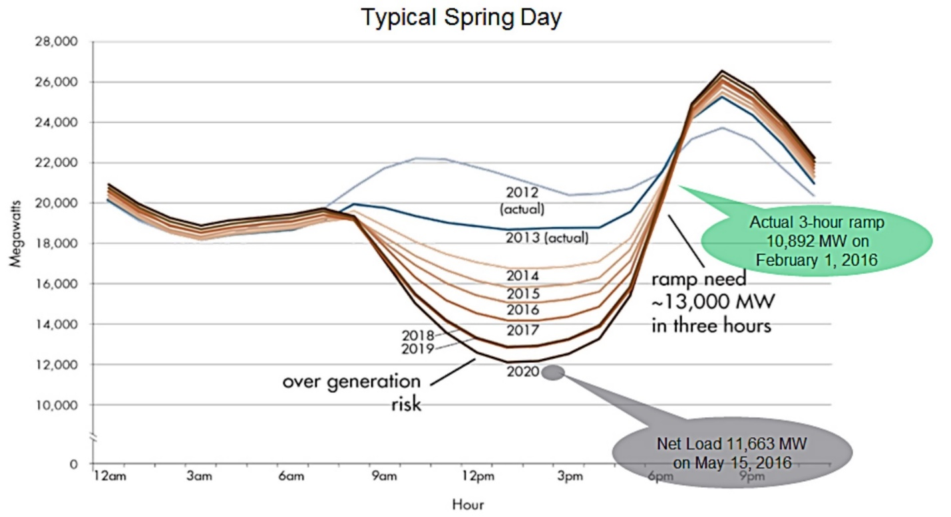

Figure 1.1: Projected Power Generation Profile of Conventional Generators in California [12]

As the amount solar power use increases over time, the ramping for conventional generators required to maintain grid stability in the afternoon increases. To increase variable renewable energy penetration beyond approximately 20-25%, additional sources of grid flexibility, must be developed [13]. One potential method of increasing grid flexibility is the use of energy storage. By storing variable renewable energy for later use, the renewable energy penetration can be increased beyond 25% while maintaining grid stability and avoiding curtailment rates of variable renewable power above 35% [7] [14].

This thesis proposes the use of an intermediate temperature reversible solid oxide fuel cell (reSOFC) based energy storage system to address the problem of integrating additional variable renewable energy. Prior studies have determined that reSOFC-based energy storage systems have roundtrip electrical efficiencies of approximately 50% [15] [16] [17]. This is an improvement over low temperature reversible polymer membrane cells, which achieve roundtrip efficiencies of approximately 30% [18]. This study proposes two advancements from previous reSOFC studies; pressurized operation to facilitate direct methanation and a co-production of hydrogen through the use of a hydrogen transport membrane, recovering high purity hydrogen during fuel cell mode for transportation applications. The net impact is a reSOFC system capable of operating at roundtrip efficiencies around 60%.

First, by using methane as the energy storage medium the existing natural gas infrastructure can be readily adapted. Secondly, the methanation reaction occurring within the reSOFC during electrolysis cell mode, reduces the energy used to preheat reactants. Likewise, the steam reformation reaction occurring within the reSOFC during fuel cell mode, decreases the waste heat generated by the system. Previous work by others has shown that this can result in benefits to the thermal management of the system by decreasing the thermal gradient across the reSOFC and may result in an increase in the electrical efficiency of the system at low current densities in electrolysis cell mode and fuel cell mode [19]. Recovering unused hydrogen during fuel cell mode using a passive pressure driven hydrogen transport membrane (HTM), increases the net efficiency of the system. Selling the hydrogen for vehicles contributes to emissions reductions in another energy sector

## Thesis Outline

Pursuant to the goal of evaluating the potential of a reSOFC-based energy storage system, the following objectives were undertaken:

1. Develop a steady-state model for a reSOFC-based energy storage system based on fundamental physical principles.
2. Characterize the impact of using methane rather than hydrogen as the primary energy carrier in a reSOFC system.
3. Characterize the impact of hydrogen coproduction with a reSOFC system.
4. Investigate benefits and trade-offs of a methane based reSOFC energy storage system as compared to state-of-the-art battery energy storage systems for large-scale management of intermittent power generation sources.

To facilitate understanding of the work done in this thesis, background information is provided in chapter 2 of this thesis and relevant literature needed to give context to the results of this analysis are given in chapter 3 of this thesis. Chapter 4 develops a steady-state model for a reSOFC-based energy storage system. Performance of the reSOFC system model is characterized in chapter 5. Chapter 6 discusses the methodology used to simulate and compare the electrical performance of a reSOFC-based energy storage system and a battery energy storage system. Chapter 7 shows the results of a comparison between the two systems.

# Background

## reSOFC

reSOFC are a type of electrochemical conversion cell that is capable of either generating electrical power from an oxidation-reduction reaction or facilitating an oxidation-reduction reaction by using electrical power. In other words, reSOFC can operate as either a solid oxide fuel cell (SOFC), subsequently called fuel cell mode, or as a solid oxide electrolysis cell (SOEC), subsequently called electrolysis cell mode. The oxidation-reduction reaction taking place within the reSOFC during fuel cell mode is shown by equation 2.1.

|  |  |  |
| --- | --- | --- |
|  |  | (2.1) |

Where is the net change in enthalpy from oxidation of hydrogen and a portion of the change in enthalpy is converted into electrical power by operation of the reSOFC in fuel cell mode. Some of the enthalpy change may be lost in the form of heat generation. The oxidation-reduction reaction in electrolysis cell mode is shown by equation 2.2.

|  |  |  |
| --- | --- | --- |
|  |  | (2.2) |

While the reaction is driven by electrical power, some of the enthalpy change may come from changes in thermal energy. This means that electrical efficiencies from the electrolysis cell mode reaction can exceed 100% when the system is operated endothermically or when heat from outside the system can be utilized [20].

These oxidation-reduction reactions can be broken up into two half reactions that divide the reSOFC into three parts. The anode, where the oxidation reaction occurs, is separated from the cathode, where the reduction reaction occurs, by the electrolyte. The reactions occur at the boundaries of the anode and cathode with the electrolyte, called the triple phase boundary. The anode and cathode are electrically conductive while the electrolyte is ionically conductive but an electrical insulator. This configuration results in oxygen ions being transported across the electrolyte while electrical current flows between the anode, cathode, and external current collectors. This is shown by figure 2.1 for the reSOFC operating in fuel cell mode.

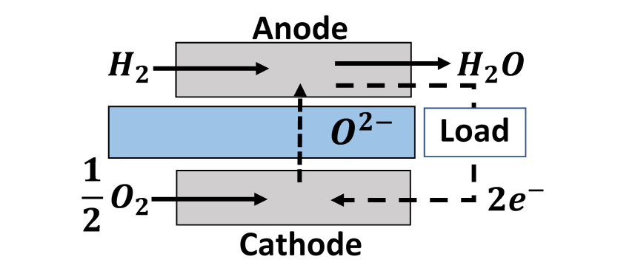

Figure 2.1: Depiction of Half Cell Reactions for reSOFC in Fuel Cell Mode.

The separate oxidation and reduction reactions in fuel cell mode are shown by equation 2.3 and 2.4 respectively.

|  |  |  |
| --- | --- | --- |
|  |  | (2.3) |
|  |  | (2.4) |

The separate oxidation and reduction reactions in electrolysis cell mode are shown by equation 2.5 and 2.6 respectively.

|  |  |  |
| --- | --- | --- |
|  |  | (2.5) |
|  |  | (2.6) |

In a reSOFC, the anode in fuel cell is the cathode in electrolysis cell mode. This causes fuel species to be physically separated from oxidants even when switch between operational modes.

While the reSOFC, being a type of Solid Oxide Cell (SOC), transports oxygen ions across the electrolyte, other types of fuel cells and electrolysis cells can use other ions. For example, Proton Exchange Membrane (PEM) fuel cells transport protons (ionized hydrogen) across the electrolyte. The type of ion that is able to flow across the electrolyte, along with other properties, is a product of the materials used to construct the electrochemical cell. In high temperature reSOFC, the use of Yttria-stabilized Zirconia (YSZ) is common [21]. However, YSZ is a poor choice of material for an electrolyte in an intermediate temperature reSOFC due to poor performance at low temperatures [22]. Material selection at low temperatures is an active area of research [23]. In this thesis, material properties and performance represent a strontium and magnesium doped lanthanum gallate (LSGM) electrolyte [24], which have higher performance at low temperatures [25]. A table showing all reSOFC system parameters is given in chapter 4.

The electrical performance of an reSOFC is dependent on the temperature, pressure, and chemical composition within the reSOFC. The Gibbs free energy, representing the maximum reversible work that may be performed by a system at constant temperature and pressure, is calculated using equation 2.7.

|  |  |  |
| --- | --- | --- |
|  |  | (2.7) |

Where is the change in specific enthalpy from a oxidation-reduction reaction, is the change in specific entropy, and is the temperature. The open circuit voltage, also called the Nernst voltage, calculates the voltage across the reSOFC when no current is flowing. It is given by equation 2.9 [26].

|  |  |  |
| --- | --- | --- |
|  |  | (2.8) |
|  |  | (2.9) |

Where F is the Faraday constant, is the number of electrons transferred per oxidation-reduction reaction, is the universal gas constant, is the pressure, is the molar fraction of a species in the reactants, and is the molar fraction of a species in the products of the oxidation-reduction reaction. This definition of the Nernst voltage is generalized to account of different oxidation-reduction reactions within the reSOFC. For a reSOFC, two electrons are transferred across the reSOFC per oxidation-reduction reaction. When ions flow across the electrolyte, ionic resistance converts a portion of the electrical potential to heat, reducing the power production in fuel cell mode, and increasing the power requirement in electrolysis mode.

The overpotential can be attributed to ohmic losses, concentration losses, and activation losses. Activation losses are caused by the activation energy of the oxidation-reduction reaction within the reSOFC, but they are not calculated in this thesis due to the high operating temperature and pressure of the reactants [27]. Ohmic loss caused by resistance of the material the flow of electrons and ions through the reSOFC converts potential energy into heat. The potential energy lost due to ohmic losses is given by equation 2.10.

|  |  |  |
| --- | --- | --- |
|  |  | (2.10) |

Where is the current and is the resistance. In electrochemical cells, it is common to normalize the resistance and current by area. The ohmic losses in a reSOFC can then be calculated by equation 2.11.

|  |  |  |
| --- | --- | --- |
|  |  | (2.11) |

Where is the current density and is the area specific resistance. Since ohmic losses linearly scale with current density, ohmic losses cause a linear increase in the overpotential with increases in current density.

Concentration losses are the result of the change in concentration of reactants and products along the length of the reSOFC. As reactants are used by the reSOFC and products are generated by the oxidation-reduction reaction, the molar fraction of reactants decreases while the molar fraction of products increases. Concentration losses are calculated by changes in the Nernst voltage along the length of the reSOFC. This means that concentration losses are automatically calculated in distributed models, but approximations of concentrations losses can be found for lumped models as well [28]. In distributed models, the chemical composition is calculated for the bulk flow at a series of nodes along the length of the reSOFC. However, additional concentration losses, called diffusion losses, are caused by a difference in the chemical composition between the bulk flow and the triple phase boundary.

To find the chemical composition at the triple phase boundary, the chemical composition at the surface of the anode and electrode are used. Those chemical compositions are calculated using Fickian diffusion. To find the rate of diffusion of each chemical species through the bulk flow, the Fuller equation is used. The Fuller equation is an empirical formula for the diffusion coefficient of binary mixtures, given by equation 2.12 and 2.13.

|  |  |  |
| --- | --- | --- |
|  |  | (2.12) |
|  |  | (2.13) |

Where is the temperature, is the pressure in either the anode or cathode, is the atomic diffusion volumes of species *I*, and is the molecular masses of species *I.* Diffusion from the surface of the anode and cathode to the triple phase boundary is also affected reactants by having to diffuse through an electrode to reach the electrolyte. The diffusion coefficient for this process is calculated using Knudsen diffusion since the mean free path of molecules traveling through pores in the electrode is longer than the width of the electrode. Diffusion coefficients for Knudsen diffusion are calculated using equation 2.14.

|  |  |  |
| --- | --- | --- |
|  |  | (2.14) |

Where is the universal gas constant, is the radius of pores in the electrode, is the temperature, and is the molecular mass. The effective diffusion constant, combining the effects of the Fuller equation and Knudsen diffusion is found using equation 2.15.

|  |  |  |
| --- | --- | --- |
|  |  | (2.15) |

Where is the tortuosity, and is the material porosity. The tortuosity is the ratio of the mean free path of molecules relative to the length of the pore. A high tortuosity means that molecules frequently collide with the walls of pores, decreasing the rate at which diffusion occurs. The porosity measures the fraction of empty space within a material. The diffusion losses are calculated with equation 2.16, using equation 2.9.

|  |  |  |
| --- | --- | --- |
|  |  | (2.16) |

Where is the molar fraction of a reactant species in the bulk fluid, and is the molar fraction of a reactant species at the triple phase boundary. In this thesis, solutions to the Fickian diffusion equation in the form of reactant and product concentrations at the triple phase boundary are taken from the literature [29].

## Methanation and Steam Reforming

The exothermic methanation reaction, creating methane using equation 2.17, and endothermic steam reformation reaction, creating hydrogen from methane using the reverse reaction, are potentially useful in managing the thermal balance of a reSOFC but also create additional design problems [30].

|  |  |  |
| --- | --- | --- |
|  |  | (2.17) |

Possible methods for using these reactions to benefit the thermal management of the system include indirect internal reforming, where reforming happens in a separate reformer section that is close to but separate from the anode in fuel cell mode, and direct internal reforming, where reforming takes place directly on the anode in fuel cell mode. Use of direct internal reforming thus requires use of anode materials that possess good catalytic properties without compromising system performance. Nickel-based anodes have been found to be able to provide sufficient activity for steam reforming without the need for any additional catalyst [31]. In this thesis, both indirect internal reforming and direct internal reforming are used. Two major issues limit the use of internal reforming in SOC: carbon deposition onto the fuel cell mode anode and the formation of large temperature gradients caused by the reformation of many reactants near the reSOFC inlet [32].

When operating a reSOFC-based energy storage system with internal methanation and reforming, carbon deposition can cause significant degradation to the anode in fuel cell mode and the cathode in electrolysis cell mode [33] [34]. During fuel cell mode, fuel species are oxidized and the chemical composition moves away from the carbon deposition boundary. During electrolysis cell mode, reactants are reduced and the chemical composition moves towards the carbon deposition boundary. Figure 2.2 shows the carbon deposition boundary at 20 bar over a variety of temperatures. The leftmost axis shows the atomic percent of hydrogen, the rightmost axis shows the atomic percent of carbon, and the bottom axis showing the atomic percent of oxygen.

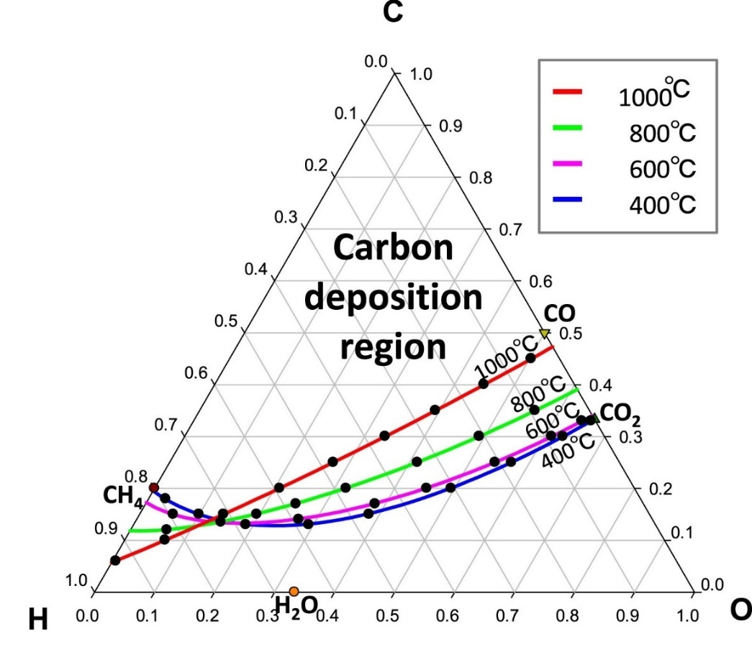

Figure 2.2: Carbon Deposition Boundary at 20 Bar [35]

The carbon deposition boundary changes with the temperature, pressure, and the chemical composition. For a given temperature, the carbon deposition reaction is chemically unfavorable below the carbon deposition boundary. This means that the carbon deposition can be avoided by selecting operating conditions that result in atomic fractions of carbon at levels below the carbon deposition boundary. When sufficient anode off-gas recirculation is used, carbon deposition can be avoided in fuel cell mode [36]. During electrolysis cell mode, fuel species are produced and the chemical composition within the reSOFC moves towards the carbon deposition boundary along the length of the reSOFC. This provides an upper limit on the steam utilization rate during electrolysis cell mode.

Large thermal gradients are another potential consequence of using internal reformation. In fuel cell mode, steam reformation can cause large thermal gradients from excessive localized cooling. In electrolysis cell mode, methanation can cause large thermal gradients from excessive localized heating. Steam reformation is more favorable at high temperatures and low pressures and methanation is favorable at low temperatures and high pressures. By selecting operating conditions that gradually reform reactants along the length of the reSOFC, large temperature gradients can be avoided in both fuel cell mode and electrolysis cell mode while still obtaining high amounts of steam reformation in fuel cell mode and methanation in electrolysis cell mode [37]. This occurs around 650° C at 20 bar, meaning that these conditions are attainable by intermediate temperature reSOFC [38].

## Hydrogen Transport Membrane

This thesis modifies existing reSOFC-based energy storage designs by adding a hydrogen transport membrane (HTM), a form of membrane separation. HTM operate by separating an inlet stream into a high purity permeate steam, with an increased purity of hydrogen, and a retentate stream, having a lower purity of hydrogen than the inlet stream. This is shown by figure 2.3.

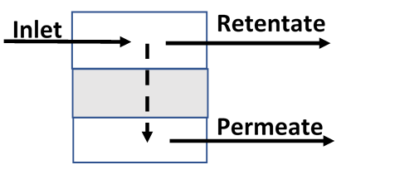

Figure 2.3: Transport Membrane Diagram

The performance of transport membranes is usually described in terms of the selectivity and permeability. The permeability describing the rate at which a molecule can diffuse through a transport membrane. The selectivity, describing how selective a membrane is in terms of the molecules that can diffuse through it, is defined by equation 2.19.

|  |  |  |
| --- | --- | --- |
|  |  | (2.19) |

HTMs can either be in the form of dense membranes, which allow ionic or molecular transport of specific chemical species through the bulk of the material, or porous membranes, which selectively diffuse chemical species through pores [39]. Material selection also plays a role in the operating range of an HTM, with common materials including polymeric membranes, metallic membranes, and ceramic membranes. Polymeric HTM operate at lower temperatures [40], making them unfit for use in a reSOFC. Metallic membranes are highly selective towards hydrogen, but they are negatively affected by the presence of carbon monoxide and hydrogen sulfides [41]. This makes metallic HTM unsuitable for use in a methane-based reSOFC. Ceramic HTM display high selectivity towards hydrogen and durability in high temperature environments, but typically have low permeabilities [42] [43]. In this thesis, a dense ceramic HTM is used to ensure the production of high purity hydrogen at high temperatures in the presence of contaminants. Dense ceramic HTM typically have durability issues in the presence of H2S and CO2 [39], but some materials have demonstrated high durability with chemical compositions comparable to those in an integrated gasification combined cycle power plant [44] [45].

## System Design

A variety of reSOFC system configurations are discussed in the literature [46] [15] [47]. Common features of these designs, and other pressurized SOFC systems, such as topping cycle fuel cell gas turbine hybrids [48], include: the thermal coupling of a electrochemical generator and a heat engine, separate reactant and exhaust storage vessels, and identical operating conditions in fuel cell mode and electrolysis mode. The proposed system design of figure 4.1 and figure 4.2 combines these elements with CO2 and hydrogen recovery in fuel cell mode, and CO2 injection for internal methanation in electrolysis mode. Operating conditions based on values in the literature [49], facilitate direct comparison of results. Specific attention is given to the operating temperature and pressure which best facilitates internal methanation in electrolysis cell mode and steam reforming in fuel cell mode.

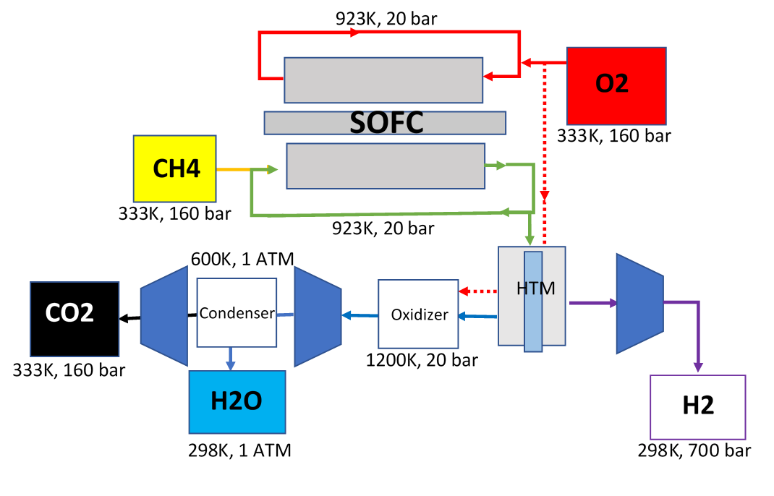

Figure 2.4: System Schematic for Fuel Cell Mode.

In fuel cell mode, pressurized methane is fed into the anode recirculation loop. There the methane mixes with partially oxidized reactants, is fully preheated using waste heat from the reSOFC, and is humidified. Inside the reSOFC, the reactant stream is partially reformed over an indirect internal reforming plate before flowing along the fuel cell mode anode and being oxidized. This can be seen in figure 2.5.

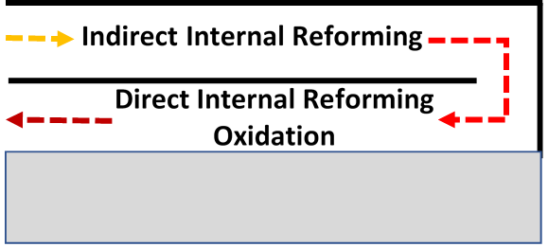

Figure 2.5: Internal Reformation Diagram

As the reactants flow along the internal reforming plate, the chemical composition reaches chemical equilibrium. After reaching the reSOFC anode, the chemical composition at equilibrium changes due to the flow of oxygen across the electrolyte. After flowing through the reSOFC, the anode reactant stream then passes through a recirculation valve, where 75% of the reactant stream is recirculated. The exhaust stream flows into an HTM, where unused hydrogen from the exhaust stream is recovered. This increases the net efficiency of the system and allows for nonelectrical demand to be met by the system. The recovered hydrogen is pressurized to 700 bar based on existing pressurized hydrogen storage technology [50] and assumed to be sold at $2/gge (gallon of gas equivalent). After flowing through the HTM, unused fuel in the retentate steam is oxidized, increasing the temperature of the exhaust stream, before flowing through a turbine. H2O is separated from the retentate stream with a condenser while CO2 is compressed and pumped into underground storage. The design of the system in electrolysis cell mode can be seen in figure 2.6.

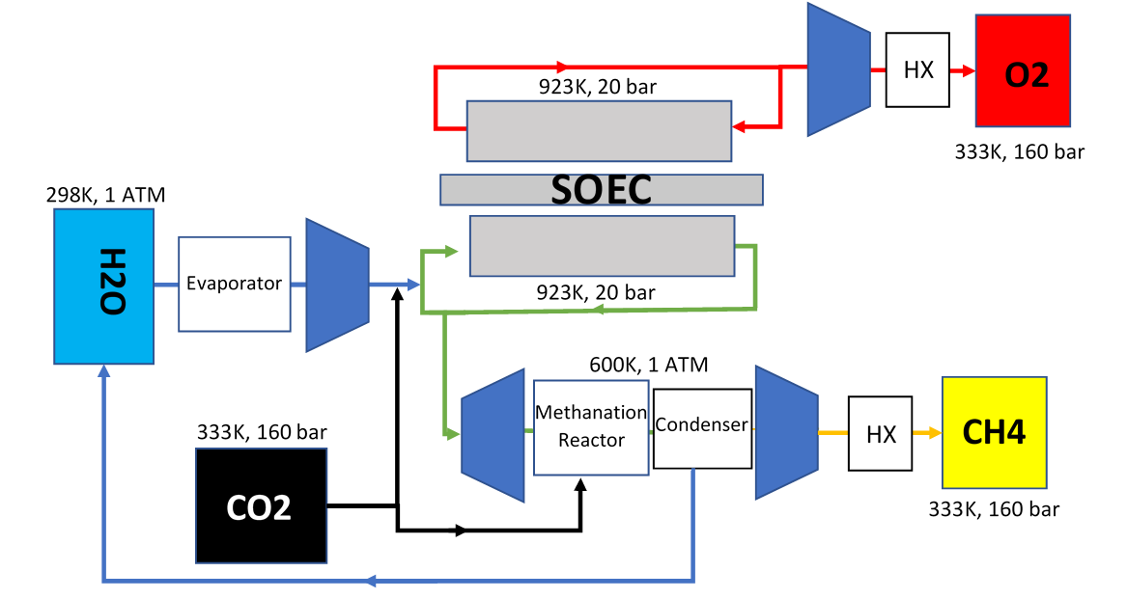

Figure 2.6: System Schematic for Electrolysis Cell Mode.

In electrolysis cell mode, CO2 is fed into the system and turned into methane through electrolysis and the methanation reaction. A mixture of CO2 and H2O is preheated using a combination of joule heating and waste heat recovery and fed into the reSOFC recirculation loop, where it mixes with partially reduced reactants. Within the reSOFC, the reactant stream is partially methanized over the indirect internal reformation plate before entering the cathode. Within the cathode, the reactants are reduced through electrolysis but only a portion of the hydrogen produced by the reSOFC is converted into methane through the methanation reaction. After exiting the reSOFC recirculation loop, parasitic losses are reduced due to the use of a turbine. Due to the high operating temperature of the reSOFC, an external methanation reactor is used to increase the molar fraction of methane in the outlet stream after exiting the turbine. This ensures compatibility with existing natural gas infrastructure without being operated at the high pressures that would be necessary to obtain the same molar fraction of methane from internal methanation alone. The remaining H2O is removed from the outlet stream by a condenser and the remaining CH4 is compressed and stored in an underground storage cavern. Waste heat from the compression of oxygen and methane is used to evaporate water.

# Literature Review

In order to provide a basis and justification for the work in this thesis, this literature review will summarize research that helped in the creation of the following reSOFC-based energy storage system model and the cost comparison to other strategies for increasing renewable energy penetration.

A variety of energy storage technologies are currently being studied in order to increase renewable penetration, including pumped hydro energy storage [51], battery energy storage [52], capacity energy storage [53], and fuel cell-based energy storage [54]. While the use of fuel cell-based energy storage to increase variable renewable energy penetration has been explored for low temperature fuel cells, these systems have roundtrip efficiencies of 30-40% at moderate current densities [18] [16] [54]. Combined with low lifespans [55], this makes PEM fuel cell-based energy storage too costly for utility scale applications. reSOFC-based energy storage has the potential to operate at higher roundtrip efficiencies over longer lifespans [56], but construction and testing of reSOFC-based energy storage systems has been limited. Boeing provided the U.S. Navy with a reSOFC-based fuel cell energy storage system in 2016 [57], but most prior work has been limited to either computational modeling of reSOFC systems or experimental results for solid oxide cells without the supporting balance of plant.

System integration studies for reSOFC-based energy storage systems incorporate many design elements from topping cycle fuel cell-gas turbine hybrids [48]. Frank et al [47] developed a model of a typical hydrogen-powered reSOFC-based energy storage system with a layout similar to a topping cycle fuel cell-gas turbine hybrid with a roundtrip efficiency of 51% and 100% system fuel utilization in fuel cell mode. The reSOFC-based energy storage system model uses an anode exhaust recirculation loop and was operated at a temperature of . With this configuration, it was found that the time required to switch from electrolysis cell mode to fuel cell mode was found to be less than five minutes.

Many system integration studies incorporate novel strategies for increasing the electrical performance of the system. Mottaghizadeh et al [58] created a reSOFC-based energy storage model based off a commercially available solid oxide cell and used latent heat storage to increase the efficiency of the system. By storing steam generated during fuel cell mode to later be used in electrolysis mode, the heating requirements of the system can be reduced. The system was able to achieve an electrical roundtrip efficiency of 54.3% when operated at atmospheric pressure and a roundtrip efficiency of 60.4% when operated at a pressure of 25 bar. Here, pressurization operation results in increased roundtrip efficiency through an increase in the Nernst voltage in fuel cell mode. While pressurization resulted in a decrease in efficiency in electrolysis mode, the increase in efficiency in fuel cell mode resulted in a net increase in the roundtrip efficiency.

One method of increasing the cost effectiveness of reSOFC-based energy storage systems is through addressing non-electrical demand, such as through combined heat and power (CHP). By using waste heat from the system to supply consumer demand for heating, the cost effectiveness of the system is increased. Perna et al [17] developed and experimentally validated a steady-state model for a distributed scale (100-200 kW) reSOFC-based energy storage system, operating at a temperature of and a pressure of 1 atm. The system achieved electrical roundtrip electrical efficiencies of 60% when operated at thermoneutral current densities and net efficiencies of 91% when used for combined heat and power (CHP).

Many experimental results have focused on cell degradation as it is a problem that needs to be addressed before reSOFC can be installed in significant quantities. Studies on reSOFC degradation serve as a limit on the current densities obtainable by a reSOFC-based energy storage system. Nguyen et al [59] created a two-cell planar stack with solid oxide cells and tested reversible operation. Through long-term aging tests at , operation in fuel cell mode resulted in a degradation rate of 0.6% per 1000 hours with a current density of and steam electrolysis resulted in a degradation rate of 0.2% per 1000 hours at . Additionally, the cyclic voltage changes from use as a reSOFC results in significant amounts of degradation. Hong et all [60] investigated the impact of long-term reversible operation in a 200 W reSOFC stack operated at for 1000 hours. They found that operation at resulted in negligible degradation rates in electrolysis mode, but that switching operational modes resulted in significant degradation. Transitioning from electrolysis mode to fuel cell mode resulted in large chemical and thermal stresses, causing fractures and delamination to occur.

Thermal and chemical stresses within the reSOFC can potentially be limited through the selection of operating conditions that promote internal methanation and steam reforming. By creating methane in electrolysis cell mode and using it in fuel cell mode, the thermal management of the system can be improved. Aguiar et al [61] developed a model of a solid oxide fuel cell with direct internal methane reformation and calculated the thermal gradient across the fuel cell in co-flow and counter-flow operation. When operating the SOFC at 1023K and atmospheric pressure with 10% pre-reformed methane, they found that cooling from direct internal reformation of methane accounted for 45% of the heat generated by the fuel cell. While this was beneficial for thermal management in co-flow operation, it resulted in significant increases to thermal gradients in counter-flow operation.

An additional complication of using internal methanation and steam reforming in a reSOFC is in selecting operating conditions that are suitable for the reaction to go in either direction depending on the chemical composition in the reSOFC. Meng Ni [62] used computational fluid dynamics and a chemical model describing the water-gas shift reaction and reversible methanation reaction to create a 2D thermal model describing a SOEC used for co-electrolysis. Performance and methanation rates were compared using inlet compositions of 25% H2O and 75% CO2 and 75% H2O and 25% CO2. They found that methanation was chemically unfavorable at SOEC operating temperatures of 1073K, 973K, and 873K at pressures of 1 atm. Under these conditions, the endothermic reverse water-gas shift reaction resulted in a decrease in the temperature gradient across the SOEC. While operation in fuel cell mode at these temperatures and pressures can result in large amounts of steam reformation, they are chemically unfavorable for methanation.

One method of increasing methanation at the high operating temperatures of solid oxide cells is through pressurization. Sun et al [63] developed a model of a pressurized SOEC for generating synthetic methane and dimethyl ether at 35 atm. The methanation reaction within the SOEC lowers the thermoneutral voltage by generating additional heat. By changing the operating temperature of the electrolysis cell from to they were able to increase the methane equilibrium concentration in the downstream gas products from 1.5% to 22.8%. This resulted in increased efficiency at low current densities, where heat generated by methanation reduces the heating demands of the system. By combining relatively low temperatures with high pressures, methanation can be chemically favorable within the reSOFC.

By finding suitable conditions for both methanation and reformation, higher roundtrip efficiencies can be achieved. Bierschenk et al [30] tested the performance of a reSOFC at and 1 atm and then modeling the performance of the system at a pressure of 10 atm, converting fuel between a H2O-CO2-rich and CH4-H2 rich mixture. They found that the exhaust stream of the fuel cell matched the chemical equilibrium prediction within the experimental error for gas chromatography when operated at 1 atm using a nickel-based electrode. The use of nickel-based components, common in SOFCs, provides enough catalytic surface area to reach chemical equilibrium along the length of the reSOFC. A model of pressurized operation at 10 atm predicted that a maximum roundtrip efficiency of 67% for the electrolysis of water could be achieved at low current densities due to the benefits of internal methanation and steam reforming.

By careful selection of operating conditions, thermal gradients can be limited while maintaining high efficiencies. Wendel et al [24] created a model of a reSOFC-based energy storage system operating at and 20 bar that used internal methanation and steam reforming. A reactant mixture is cycled from a H2O-CO2 rich mixture to a CH4-H2 rich mixture with the use of both a direct internal reformer and an indirect internal reformer. With these design choices and operating conditions, the rate of methanation and steam reforming were more evenly distributed across the length of the reSOFC, resulting in lower thermal gradients. Wendel et al [46] later used the same reSOFC-based energy storage system model to find the economic performance of the system. They found that the reSOFC-based energy storage system was able to meet DOE technical targets for energy storage for given ratios of power generation in fuel cell mode to power storage in electrolysis cell mode.

One objective of this thesis is to find the economic performance of a reSOFC-based energy storage system when using more realistic demand and renewable power profiles. In order to compare a reSOFC-based energy storage system with other energy storage technologies for increasing the renewable energy penetration, use profiles are generated for conventional generators, renewable power, and energy storage and the cost of the system is compared relative to the total power that it can generate. Denholm and Margolis [7] studied the amount of energy storage that would be required to keep PV curtailment to acceptable levels when increasing renewable penetrations up to 50% in California by 2030. To accomplish this, they took hourly load, wind, and solar data from the Low Carbon Grid Study and scaled the total yearly energy demand to 320 terawatt-hours (TWh) to account for population growth. Using the National Renewable Energy Lab model REFlex, they found that 19 GW of storage would be required to achieve 50% PV penetration in California under a high grid flexibility test case. This methodology can be applied to use of reSOFC-based energy storage systems.

The studies summarized above highlight the potential of reSOFC-based energy storage, strategies for increasing system performance, and methods for evaluating performance at utility scale. This study aims to incorporate the use of internal methanation and steam reformation to increase the efficiency of the system while simplifying thermal management. Additionally, increasing the value of a reSOFC-based energy storage system through hydrogen production will be investigated. Finally, the value of a reSOFC-based energy storage system will be compared to other energy storage technologies by use of real-world data.

# reSOFC System Model Methodology

## System Model

To find the performance of the selected reSOFC energy storage system design using internal methanation and steam reforming, separate steady state system models were created for fuel cell mode and electrolysis cell mode. The reSOFC component is modeled through a spatially discretized non-dimensional isothermal solid oxide cell model. Additional steady state component models governing the balance of plant, create a steady state system model. Due to the fundamentally modular nature of SOC technology, the performance of a single cell repeat unit can be used to appropriately estimate the state of the entire stack in a grid scale reSOFC system.

### System Model Assumptions

In the creation of system models, the following assumptions and constraints apply:

1. Temperature is constant within the SOC
2. Chemical equilibrium is reached in each node.
3. The entire cell is an isopotential surface.
4. Joule heating meets any supplemental heating requirements for which waste heat is unavailable.
5. Negligible thermal losses to the environment.
6. Negligible participation of CO in the electrochemistry.

The chemical composition within a solid oxide cell has been found to reach chemical equilibrium under similar conditions to those found in this reSOFC model [30]. When operating with internal reforming in fuel cell mode and internal methanation in electrolysis cell mode, electrochemical transport changes the equilibrium concentrations across the reSOFC. Over the length of the reSOFC, the effects of direct internal reforming are found by calculating chemical equilibrium composition over a series of nodes representing constant volumes along the length of the reSOFC. The effects of indirect internal reforming are found by finding the chemical composition at a single node that represents the indirect internal reforming plate. The primary chemical reactions occurring are described by the steam reforming reaction, carbon deposition reaction, and water-gas shift reaction. The steam reformation of methane is described by equation 4.1, the carbon deposition reaction is described by equation 4.2, and the water-gas shift reaction is described by equation 4.3.

|  |  |  |
| --- | --- | --- |
|  |  | (4.1) |
|  |  | (4.2) |
|  |  | (4.3) |

While the inclusion of dry reformation can significantly increase the rate of methanation within an SOFC under some operating conditions [64], it is unnecessary in this model due to the assumption of reaching chemical equilibrium. For a model that did not assume that the chemical composition reached equilibrium, the inclusion of dry reformation may be important. The equilibrium coefficient governing each reaction are given by equation 4.4-4.6.

|  |  |  |
| --- | --- | --- |
|  |  | (4.4) |
|  |  | (4.5) |
|  |  | (4.6) |

Where is the partial pressure of species x, R is the universal gas constant, T is the temperature, and is the change in the standard Gibbs free energy of the reaction. These equilibrium coefficients are used to create and solve a system of equations iteratively using Newton’s Method, shown by equations 4.7-4.10.

|  |  |  |
| --- | --- | --- |
|  |  | (4.7) |
|  |  | (4.8) |
|  |  | (4.9) |
|  |  | (4.10) |

Once the values of have converged, the reaction rates required to reach chemical equilibrium have been found. This method of calculating the chemical equilibrium has been found to accurately describe the exhaust flow composition of SOFCs at a range of operating temperatures [65] [66].

Equation 4.11 describes the energy balance resulting from this set of chemical reactions.

|  |  |  |
| --- | --- | --- |
|  |  | (4.11) |

Where is the enthalpy of reaction for the steam reforming reaction, is the enthalpy of reaction for the carbon deposition reaction, and is the enthalpy of reaction for the water-gas shift reaction. This results in a modified thermal balance by changing the dependence of the reSOFC on external heating and cooling. This shown by equation 4.12.

|  |  |  |
| --- | --- | --- |
|  |  | (4.12) |

Where is the heat or cooling generated by operation of the reSOFC, is the amount of external heating or cooling supplied by heat exchangers, and is the amount of heating supplied through joule heating. The amount of power used by the system for joule heating is shown by equation 4.13.

|  |  |  |
| --- | --- | --- |
|  |  | (4.13) |

Where is the amount of joule heating required by component *I*. Joule heating is used to maintain thermoneutral operation of the system by preheating inlets to the reSOFC, heating the reSOFC component, and heating the evaporator in electrolysis cell mode. must be greater than zero.

### reSOFC

The performance of a planar reSOFC in estimated using a steady-state model that is spatially discretized in the primary flow direction. The assumption of uniform parallel flow simplifies the modeling requirement to one dimension. Similar but separate electrolysis mode and fuel cell mode models are detailed in the following section. The reaction resulting from use of the reSOFC, in both fuel cell mode and electrolysis cell mode, is described by equation 4.14.

|  |  |  |
| --- | --- | --- |
|  |  | (4.14) |

In fuel cell mode, H2O is created from O2 and H2. In electrolysis cell mode, the reaction occurs in the reverse direction. The reaction is exothermic in fuel cell mode and endothermic in electrolysis cell mode. The reaction rate is related to the net steam utilization [67] or fuel utilization [61] by equations 4.15 and 4.16 and to the current through the Faraday constant by equation 4.17.

|  |  |  |
| --- | --- | --- |
|  |  | (4.15) |
|  |  | (4.16) |

Where and are the rates at which the electrolysis and fuel cell reactions occur and describes the flowrate of species into the anode recirculation loop from the reactant inlet stream. The reactant inlet stream is composed of fresh fuel or steam. For example, this would be calculated based on the rate CH4 was fed into the reSOFC recirculation loop from underground storage in fuel cell mode. Due to recirculation, the net utilization rate of steam or fuel is higher than the single pass utilization. The current flow over the entire surface of the reSOFC can then be described by equation 4.17.

|  |  |  |
| --- | --- | --- |
|  |  | (4.17) |

Where R is the reaction rate by the reSOFC and F is the Faraday constant.

As reactants are consumed across the length of the cell, the underlying chemical potential changes and a non-linear current distribution develops to maintain the equipotential constraint. The local voltage, at node n, is found using equation 4.18 for fuel cell mode and equation 4.19 for electrolysis cell mode.

|  |  |  |
| --- | --- | --- |
|  |  | (4.18) |
|  |  | (4.19) |

Since the SOC is assumed to be an isopotential surface, the current distribution is found by iteratively changing an assumed current density until the voltage is equal at all nodes.

The Nernst voltage, accounting for the change in the fuel cell voltage from the chemical composition of the bulk flow and the operating temperature and pressure, is described by equation 4.20 and 4.21.

|  |  |  |
| --- | --- | --- |
|  |  | (4.20) |
|  |  | (4.21) |

Where is the universal gas constant, T is the temperature, P is the pressure, and is the molar fraction of species , is the enthalpy of formation of species , and is the entropy of formation of species . The Nernst voltage is calculated using the chemical composition at the outlet of each node. The ohmic losses accounts for the voltage change caused by the electrical resistance of the electrolyte, anode, cathode, and accompanying equipment. Ohmic losses are described by equation 4.22.

|  |  |  |
| --- | --- | --- |
|  |  | (4.22) |

Where is the local current density, and is the area specific resistance.

While the Nernst voltage calculation in equation 4.20 and 4.21 account for the bulk flow of material through the fuel cell, the difference in concentrations at the surface of the triple phase boundary compared to the bulk flow cause additional voltage losses. These diffusion losses are calculated with equation 4.23 in the reSOFC cathode and equation 4.24 in the reSOFC anode based on the method described in [68].

|  |  |  |
| --- | --- | --- |
|  |  | (4.23) |
|  |  | (4.24) |

Where is the molar fraction of species in the bulk fluid and is the molar fraction of species at the triple phase boundary. The concentration at the triple phase boundary is solved in terms of the concentration at the surface of the electrolyte, which can be found from the concentration in the bulk fluid. The concentration of hydrogen and steam at the surface are given by equation 4.25 and the concentration at the triple phase boundary are given by equation 4.26.

|  |  |  |
| --- | --- | --- |
|  |  | (4.25) |

Where J is the current density, is the pressure in the anode, is the diffusion coefficient of species i, and is the height of the channel within the anode. The molar fraction of hydrogen decreases in fuel cell mode and increases in electrolysis cell mode while the molar fraction of steam increases in fuel cell mode and decreases in electrolysis cell mode.

|  |  |  |
| --- | --- | --- |
|  |  | (4.26) |

Where is the effective diffusion coefficient, including Knudsen diffusion, and is the thickness of the anode. In the cathode, the concentration of oxygen is found using equations 4.27 and 4.28.

|  |  |  |
| --- | --- | --- |
|  |  | (4.27) |
|  |  | (4.28) |

The diffusion coefficient of each species is calculated using the following method. First binary diffusion coefficients are calculated using the Fuller equation, shown by equation 4.29 and 4.30.

|  |  |  |
| --- | --- | --- |
|  |  | (4.29) |
|  |  | (4.30) |

Where are the atomic masses of atoms making up species , are the atomic radii of atoms making up species , and T is the temperature of the bulk fluid. Values for the atomic radii and the atomic masses are from the literature [69]. To account for the different species within the anode, equation 4.31 is used.

|  |  |  |
| --- | --- | --- |
|  |  | (4.31) |

The effective diffusion coefficient, accounting for both the difficulty in diffusing through the pores of the electrolyte at the triple phase boundary and diffusion across a concentration gradient, is then found using equations 4.32 and 4.33.

|  |  |  |
| --- | --- | --- |
|  |  | (4.32) |
|  |  | (4.33) |

Where is the radius of pores within the electrolyte, is the tortuosity, and is the material porosity. Since the effective diffusion coefficients are a function of the chemical composition within the reSOFC, they can not be treated as constants and must be calculated at each node.

The heat generated by the oxidation reduction reaction within the reSOFC can be expressed in terms of the current, shown by equation 4.34.

|  |  |  |
| --- | --- | --- |
|  |  | (4.34) |

After the current distribution and voltage are found, the electrical efficiency of the oxidation-reduction reaction within the reSOFC component can be found. This is shown by equation 4.35 for fuel cell mode and 4.36 for electrolysis cell mode.

|  |  |  |
| --- | --- | --- |
|  |  | (4.35) |
|  |  | (4.36) |

Where is the rate of the H2O splitting reaction and is the amount of joule heating required to maintain thermal equilibrium after accounting for the heat generated by ohmic losses. Joule heating results in an increase in the electrical power used by the system and decreases the effective electrical efficiency of the reSOFC. Due to differences in the net enthalpy change when operating a methane-based reSOFC compared to a hydrogen-based reSOFC, the electrical efficiency of the reSOFC component is given by equation 4.37 and 4.38.

|  |  |  |
| --- | --- | --- |
|  |  | (4.37) |
|  |  | (4.38) |

Where is the enthalpy of species *i*, is the molar flow rate of species *i* into the reSOFC, and is the molar flow rate of species *I* out of the reSOFC anode. Since equations 4.37 and 4.38 account for the difference in the net enthalpy change while 4.35 and 4.36 do not, the difference between the two efficiency calculation methods shows the impact of the methanation and reformation reactions on the efficiency of the reSOFC.

### Compressor

Compressors are used throughout the reSOFC system to pressurize reactant gases up to the operating pressure of the reSOFC and to store product gases. The compressor component model calculates the performance of a compressor assuming a constant isentropic efficiency for all pressure ratios and mass flow rates. Likewise, it is assumed that chemical composition does not impact the performance of the compressor. To calculate compressor properties, first the temperature is calculated assuming isentropic compression. This is shown by equation 4.39.

|  |  |  |
| --- | --- | --- |
|  |  | (4.39) |

Where is the inlet temperature, is the outlet pressure, is the inlet pressure, and is the heat capacity ratio. The enthalpy of the compressed gas is then found using equation 4.40.

|  |  |  |
| --- | --- | --- |
|  |  | (4.40) |

Where is the enthalpy of the gas exiting the compressor assuming isentropic compression, is the enthalpy of the gas entering the compressor, and is the isentropic efficiency of the compressor. The work done by the compressor is found using equation 4.41.

|  |  |  |  |
| --- | --- | --- | --- |
|  |  |  | (4.41) |

The temperature of the gas after compression is found using equation 4.42.

|  |  |  |
| --- | --- | --- |
|  |  | (4.42) |

Where is the specific heat of the gas at and is the number of moles. The specific heat is calculated at the temperature of the gas assuming isentropic compression. When compressors are used to compress gasses over large pressure ratios, such as when exhaust is compressed to 160 bar for underground storage or separated hydrogen is compressed to 700 bar, intercooling is used to reduce the amount of power used by the compressors. To simulate the effect of intercooling during compression, compression is calculated over three stages with cooling to 373K occurring between each stage. This approximates the use of liquid water as a coolant.

### Turbine

Turbines are used by both modes of the reSOFC system to convert waste heat into electrical power. This increases the efficiency of the system by decreasing the net electrical power used by the balance of plant. The turbine component model calculates the performance of a turbine assuming a constant isentropic efficiency over all pressure ratios and mass flow rates. Likewise, it is assumed that chemical species doesn’t impact the performance of the turbine. The temperature of inlet gases after isentropic expansion is given by equation 4.34. The enthalpy of gases after exiting the turbine are given by equation 4.43.

|  |  |  |
| --- | --- | --- |
|  |  | (4.43) |

Where is the enthalpy of the gases exiting the turbine assuming purely isentropic expansion and is the isentropic efficiency of the turbine. The work extracted from the gas flowing through the turbine is described by equation 4.44.

|  |  |  |
| --- | --- | --- |
|  |  | (4.44) |

Finally, the temperature of the gases as they exit the turbine is given by equation 4 from the compressor component model section. The turbine is assumed to have a maximum turbine inlet temperature of 1200K.

### Evaporator

In electrolysis cell mode, the reSOFC system must convert stored liquid water into steam. To meet this need, an evaporator component model is used. The evaporator component model calculates the amount of heat needed to boil liquid water into steam based on the chemical reaction for boiling, given by equation 4.45.

|  |  |  |
| --- | --- | --- |
|  |  | (4.45) |

Where is the heat of vaporization for water. The energy required to boil liquid water is either supplied by the waste heat from other components or through joule heating.

### Condenser

In both electrolysis cell mode and fuel cell mode, the reSOFC system must remove water from the exhaust. The is accomplished by cooling exhaust gases to below the dew point of water, which may be possible through expelling waste heat into the water reservoir. By removing water from the product stream in electrolysis cell mode, the reactant stream in fuel cell mode contains a higher concentration of methane and avoids the logistical issues of trying to store steam in underground storage caverns. This results in a higher molar fraction of hydrogen due to the steam reformation reaction. The condenser component model assumes that 100% of steam in the exhaust stream can be separated from in fuel cell mode and in electrolysis cell mode. Electrical power use from cooling fans and pumps are assumed to be negligible.

### Oxidizer

Despite the use of anode off-gas recirculation, unutilized fuel remains in the reSOFC exhaust. Due to the low concentration of fuel species in the exhaust stream, an oxidizer is used instead of a more conventional combustor. The oxidizer model calculates the outlet temperature and amount of oxygen required assuming complete combustion of fuel species, including , , and . The combustion reactions for these chemicals are given by equation 4.46-4.48.

|  |  |  |
| --- | --- | --- |
|  |  | (4.46) |
|  |  | (4.47) |
|  |  | (4.48) |

Where is the heat of reaction for the combustion of . The enthalpies of these reactions are given by table 4.2. The required flow rate of oxygen is shown by equation 4.49.

|  |  |  |
| --- | --- | --- |
|  |  | (4.49) |

Where is the rate of the methane combustion reaction, is the rate of the CO combustion reaction, and is the rate of the hydrogen combustion reaction. The net heat generated by the oxidizer is given by equation 4.50.

|  |  |  |
| --- | --- | --- |
|  |  | (4.50) |

From this, the outlet temperature is calculated and shown by equation 4.51.

|  |  |  |
| --- | --- | --- |
|  |  | (4.51) |

Where is the specific heat of the inlet stream at the inlet temperature and is the molar flow rate.

### HTM Component Model

To test the potential effectiveness of this hydrogen recovery through the use of an HTM, an HTM component model function was created and the efficiency of the reSOFC system in fuel cell mode was found over a range of HTM pressure differences. Given the high operating temperature of the reSOFC and benefits of maintaining high hydrogen purity, a high temperature HTM material with high / selectivity was chosen. This model assumes that the inlet stream spends enough time in the HTM to reach equilibrium. For the operating conditions of the reSOFC, this would be consistent with a dense ceramic HTM [41]. In this model it is assumed that the HTM has an / selectivity of 5000 at a temperature of 923K. Additionally, it is assumed that the / selectivity can be applied to all species in the reSOFC exhaust.

The flow rate across the membrane is found by finding the flow rate that would achieve an equal partial pressure of hydrogen on both sides of the membrane. Due to the known ratio of hydrogen to contaminants that cross the HTM, the partial pressure of hydrogen is known on both sides of the HTM. The partial pressure of hydrogen on the other side of the HTM is found using equation 4.52.

|  |  |  |
| --- | --- | --- |
|  |  | (4.52) |

Where is the pressure in the hydrogen permeate stream of the HTM, also called the HTM pressure in this thesis. The partial pressure of hydrogen at the outlet of the retentate stream must be equal to the partial pressure of hydrogen in the permeate stream of the HTM, shown by equation 4.53.

|  |  |  |
| --- | --- | --- |
|  |  | (4.53) |

The flow rate of hydrogen across the membrane can then be found with equation 4.54.

|  |  |  |
| --- | --- | --- |
|  |  | (4.54) |

Where is the pressure on the feed side of the HTM, is the flow rate of hydrogen in the feed stream, is the total molar flow rate in the feed stream, and is the proportion of the actual flow to the ideal maximum flow, assumed to be 0.5 in this model. The flow of contaminants, meaning species other than hydrogen, across the HTM is given by equation 4.55.

|  |  |  |
| --- | --- | --- |
|  |  | (4.55) |

Using the assumed selectivity, the HTM can produce hydrogen at a purity consistent with use by PEM fuel cells [70].

### Model Parameters

To obtain accurate results with the reSOFC system model described in section 4 of this thesis, the value of parameters used by the system model are selected from the literature and shown in table 4.1.

***Table 4.1: List of Component Parameters Used by System Model***

|  |
| --- |
| Design Parameter |
| Stack ASR | 0.31 Ω/ [71] [72] |
| Tortuosity | 3 [73] |
| Material Porosity | 26% [73] |
| Turbine Efficiency | 88% [74] |
| Compressor Efficiency | 80% [74] |
| AC-DC Conversion | 98% [75] |
| Maximum Turbine Inlet Temperature | 1200K [76] |
| HTM Selectivity | 5000 [41] |
| Recirculation Rate | 75% |
|  |  |
|  | - |
|  |  |
|  |  |
|  |  |
|  |  |
|  |  |
| reSOFC Temperature | 923K |
| reSOFC Pressure | 20 bar |
| Water Reservoir Temperature | 298K |
| Underground Storage Temperature | 333K |
| Underground Storage Pressure | 160 bar |
| Hydrogen Storage Temperature | 298K |
| Hydrogen Storage Pressure | 700 bar |

## Carbon Deposition Boundary Limitations

To achieve a high rate of internal methanation, the carbon deposition boundary was used as an upper limit on the ratio of hydrogen and oxygen to carbon within the reSOFC. This was done by varying the amount of CO2 fed into the reSOFC at a single pass steam utilization of 77% and selecting a composition that resulted in a high amount of methanation while still maintaining an arbitrary margin of safety between the operating point and the carbon deposition region. Using this method, a molar fraction of 37% methane was achieved when using 0.286 moles of CO2 for every mole of steam in the inlet stream. This creates an outlet composition consisting of 79% hydrogen, 10% oxygen, and 11% carbon. While further optimizations may be possible, this was found to be satisfactory for the purposes of this thesis. Using figure 2.2, it can be seen that this does not cross the carbon deposition boundary at or . This is consistent with the results and methodology of existing literature on internal methanation within reSOFCs [37]. To independently verify that this chosen operating point does not cross the carbon deposition boundary, the molar fraction of carbon is calculated along the anode in fuel cell mode and the cathode in electrolysis cell mode.

# reSOFC System Model Results

Here, the performance of a reSOFC using methane is compared to a reSOFC with the same configuration using hydrogen. The model for the reSOFC and the calculations used to maintain chemical equilibrium are described in the chapter 4 of this thesis. In this section, a hydrogen-based reSOFC and a methane-based reSOFC are compared at constant reactant flow rates to characterize cell performance over a range of utilization rates. This shows how the performance of each system changes in relation to each other with the choice of utilization rates in fuel cell mode and electrolysis cell mode. Additionally, the performance of each system is compared over a range of reactant flow rates when using utilization rates that are typical of real solid oxide cell systems. This allows for characterization of the performance of each system under conditions that are more similar to a real use case. Significant differences in system performance exist due to differences in the enthalpy of reaction of methane and hydrogen and the chemical composition within the reSOFC in each system.

## Cell Model Results

In this comparison, the reSOFC has a constant reactant flow rate and a varied utilization while maintaining a 75% exhaust recirculation rate. Reactants are recirculated in order to increase the S2C ratio within the methane-based reSOFC and reduce the amount of unused fuel that leaves the anode recirculation loop. While carbon deposition-based degradation is not a concern in the hydrogen-based reSOFC, exhaust recirculation has been found to result in an increase in the electrical efficiency of a hydrogen-based reSOFC system [77]. In this thesis, exhaust recirculation is used at the same rate in both systems and allows for a more direct comparison between the two systems because the configuration of components within each system is the same. The reSOFC is operated at 923K for both the methane-based system and the hydrogen-based system. The hydrogen-based reSOFC is operated at pressure of 1 bar and 20 bar to show the effect of increased pressure on reSOFC performance. Due to the limitations in operating conditions imposed by the carbon deposition boundary, the effect of pressurization on the efficiency is not tested and the methane-based reSOFC is only operated at a pressure of 20 bar. Operation at lower pressures would result in operating closer to the carbon deposition boundary and change the chemical favorability of the methanation and steam reformation reactions in ways that would inhibit the thermal management of the system. In fuel cell mode, decreased pressure would cause an increase in the rate of methane reformation and create undesirable thermal gradients. In electrolysis cell mode, decreased pressure would decrease the molar fraction of methane in the exhaust stream.

### Fuel Cell Mode

In fuel cell mode, results are found for an inlet flow rate of of methane per of active area , and a inlet flow rate of hydrogen per of active area in the hydrogen-based reSOFC. This difference in flow rates accounts for the effective flow rate of hydrogen into the methane-based reSOFC assuming 100% conversion of methane to hydrogen through the steam reformation reaction and water-gas shift reaction. This results in a higher enthalpy change within the hydrogen-based reSOFC but allows for comparison of the systems at the same current density. This means that resistive losses are the same for both systems at the same current density. Figure 5.1 shows the operating voltage of the reSOFC with net fuel utilization rates between 1% to 99.75% using a constant fuel flow rate for systems using pressurized hydrogen, unpressurized hydrogen, and pressurized CH4. Changes in the voltage with increased current density are the result of a combination of resistance-based losses and changes in the chemical composition within the reSOFC.

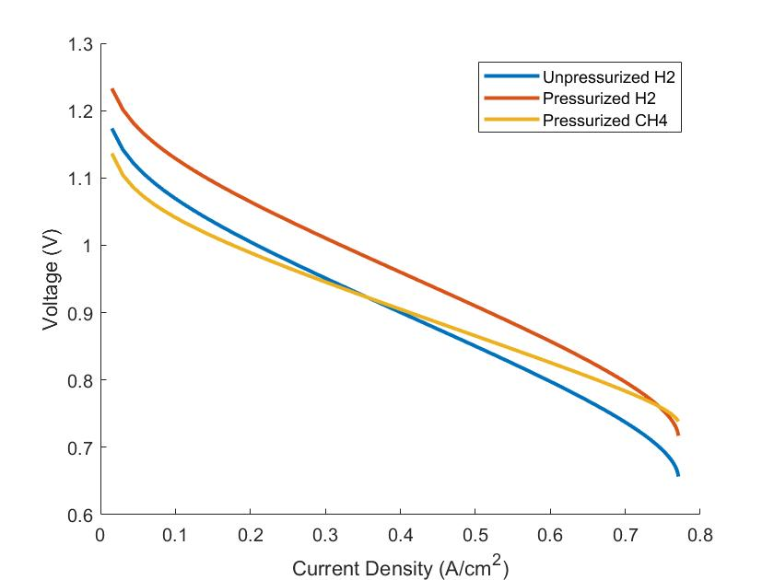

Figure 5.1: reSOFC Voltages in Fuel Cell Mode.

The difference in voltage between the pressurized hydrogen and unpressurized hydrogen in figure 5.1 can be attributed to differences in the Nernst voltage, shown by equation 4.21. Due to the properties of the natural logarithm when species concentrations and operating temperatures are the same, the effect of differences in pressure can be separated into a constant factor:

|  |  |  |
| --- | --- | --- |
|  |  | (5.1) |

This results in a constant voltage difference between the pressurized hydrogen-based system and the unpressurized hydrogen-based system. The difference between the CH4-based system and the hydrogen-based system can be attributed to differences in the chemical composition along the length of the reSOFC. At low fuel utilization rates, the concentration of hydrogen is diluted by the presence of CO, CO2, CH4, and additional H2O. This results in the CH4-based system operating at a lower voltage compared to both the pressurized and unpressurized hydrogen-based systems.

While the use of methane dilutes the amount of H2 at the reSOFC anode inlet, it also creates a more even distribution of hydrogen over the reSOFC. At very high fuel utilization rates, the steam reformation reaction significantly reduces the amount of H2O present within the reSOFC and causes the CH4-based reSOFC to operate at higher voltages than the pressurized hydrogen-based reSOFC. Assuming complete chemical conversion of methane, the net chemical reaction at a fuel utilization of 100% is given by equation 5.2. The net chemical reaction is for a hydrogen-based reSOFC is given by equation 5.3.

|  |  |  |
| --- | --- | --- |
|  |  | (5.2) |
|  |  | (5.3) |

The difference between equation 5.2 and 5.3 results in a difference in the concentration of H2O between a hydrogen-based reSOFC and methane-based reSOFC at the same fuel utilization rate. This results in a higher Nernst voltage in the methane-based reSOFC at high fuel utilization rates using equation 4.21. This can be seen in figure 5.2, calculated at a single pass fuel utilization of 95%. The figure on the left shows a hydrogen-based system and the figure on the right shows the CH4-based system.

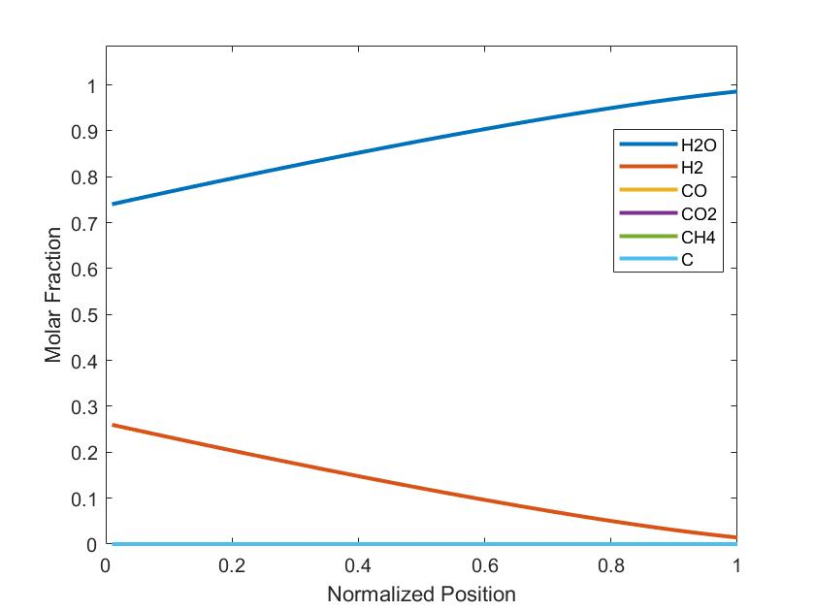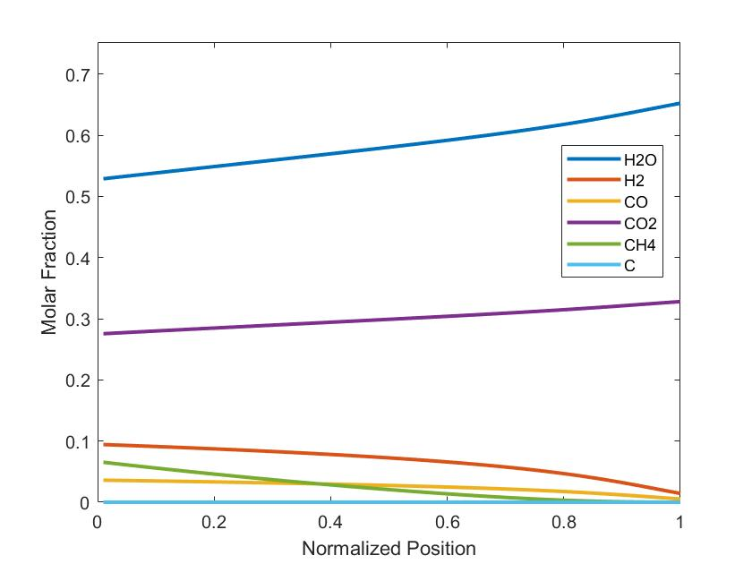

Figure 5.2: Chemical Composition Along reSOFC in Fuel Cell Mode at 95% Fuel Utilization.

When using CH4, the molar fraction of hydrogen gradually decreases until the methane is fully reformed. When this occurs, the molar fraction of hydrogen decreases more quickly. Compared to using hydrogen, the molar fraction of hydrogen is lower when using CH4 but also more consistent over the length of the reSOFC. At the inlet, much of the fuel flowing into the reSOFC is in the form of CH4. At the outlet, the molar fraction of CH4 and CO are close to zero so the amount of hydrogen at the outlet of the reSOFC is roughly the same when using hydrogen or methane as fuel. It is important to note that the molar fraction of carbon of approximately . The low magnitude of this value suggests that the carbon deposition reaction is sufficiently unlikely as to not cause carbon deposition related degradation issues in the described methane-based reSOFC system during fuel cell mode.

While the presence of CO2, CH4, and CO in the reSOFC anode imply that the molar fraction of hydrogen is significantly lower in the CH4-based reSOFC, the steam reformation and water-gas shift reaction reduce the amount of water present within the reSOFC anode as suggested by equation 5.2 and 5.3. Due to the presence of the molar fraction of H2O in equation 4.21, this results in the methane-based reSOFC operating at a higher voltage at very high fuel utilization rates. Additionally, the more even distribution of hydrogen results in a more even current distribution. While the use of steam reformation has potential benefits, the effect is highly dependent on the chosen operating conditions. At 923K and 20 bar, methane is gradually reformed along the length of the reSOFC at high fuel utilization rates. Increasing the temperature or decreasing the pressure would increase the rate of methane reformation over the indirect internal reformer, resulting in higher hydrogen concentrations near the anode inlet. This would result in current distributions more like the hydrogen-based reSOFC and potentially lead to steep temperature gradients and uneven current density distributions [61].

Due the chemical composition along the methane-based reSOFC changing with changes to the fuel utilization rate, the impact of reformation on the energy balance of the system changes with the fuel utilization rate. This results in a difference between the electrical efficiency of the hydrogen oxidation-reduction reaction in the reSOFC, calculated with equation 4.35, and the electrical efficiency of the conversion of fuel into electrical power, calculated with equation 4.37, that changes with the fuel utilization rate. Figure 5.3 shows the electrical efficiency of the oxidation reaction and the electrical efficiency of the reSOFC with methane and hydrogen over a range of fuel utilization rates.

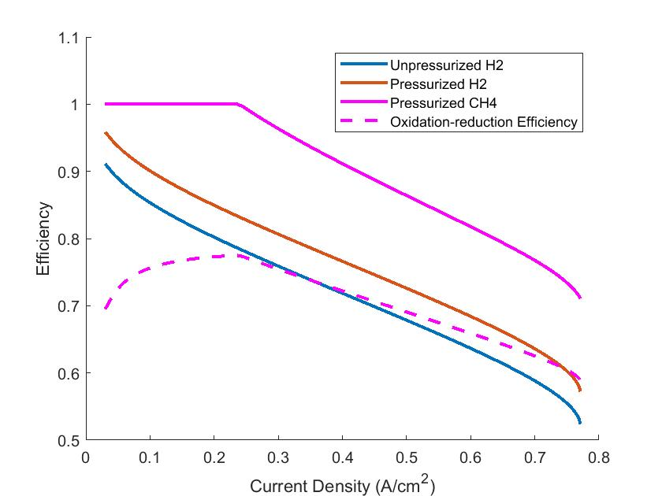

Figure 5.3: Efficiency of the reSOFC in Fuel Cell Mode.

As suggested by the voltage, shown in figure 5.1, the methane-based reSOFC is less efficient at most fuel utilization rates when the impact of reformation is neglected. When the impact of reformation is included, the methane-based reSOFC is more efficient than the hydrogen-based reSOFC. This is due to the energy content of methane combustion being 19% lower than the combustion of hydrogen that would be created by complete reformation. The change in impact of the reformation reaction with fuel utilization rate can be attributed to differences in the chemical composition at the outlet of the reSOFC.

At low fuel utilization rates, a significant amount of methane is reformed on the indirect internal reforming plate, but hydrogen produced by the reaction is not used by the reSOFC. This results in endothermic operation at low fuel utilization rates, causing a decrease in the oxidation-reduction reaction efficiency and an electrical efficiency of 100% for the reSOFC under thermoneutral operation. Low fuel utilization rates like these are outside of typical values for fuel cells and do not reflect the performance of the system under normal conditions. More hydrogen is used by the system at higher fuel utilization rates, driving the methanation reaction forward with direct internal reforming and generating additional heat from the increased rate of the oxidation-reduction reaction. This results in a gradual decrease between the efficiency of the oxidation-reduction reaction and the electrical efficiency of the reSOFC at high fuel utilization rates.

### Electrolysis Cell Mode

In electrolysis cell mode, the operation of the system is affected by the creation of water and removal of hydrogen through the methanation and water-gas shift reactions in a methane-based reSOFC. This can be seen by the reverse reactions of equations 5.2 and 5.3. Since the methane-based reSOFC consumes 50% less steam than the hydrogen-based reSOFC assuming complete methanation, the methane-based reSOFC can achieve the same current density at a lower steam utilization rate due to the effects of off-gas recirculation. While this suggests that the flow rate of steam could be decreased in the methane-based reSOFC system, doing so would result in crossing the carbon deposition boundary at high steam utilizations. In effect, this means that a methane-based reSOFC is able to achieve higher current densities than a hydrogen-based reSOFC for the same reactant flow rate in electrolysis cell mode. Additionally, the net enthalpy change in the reactants necessitates operating at higher current densities in order to achieve the same rate of power storage.

For this comparison between a hydrogen-based and methane-based system, the hydrogen-based system is operated at single pass steam utilization rates between 0.05% and 99.5% while the methane-based reSOFC is operated at single pass steam utilization rates between 0.05% and 77%, due to the limitations imposed by the carbon deposition region. Both systems recirculate 75% of reactants to reduce parasitic losses to the balance of plant when using realistic steam utilization rates. Figure 5.4 shows the voltage of the CH4 and hydrogen-based reSOFC using an inlet flow of into the methane-based reSOFC and hydrogen-based reSOFC.

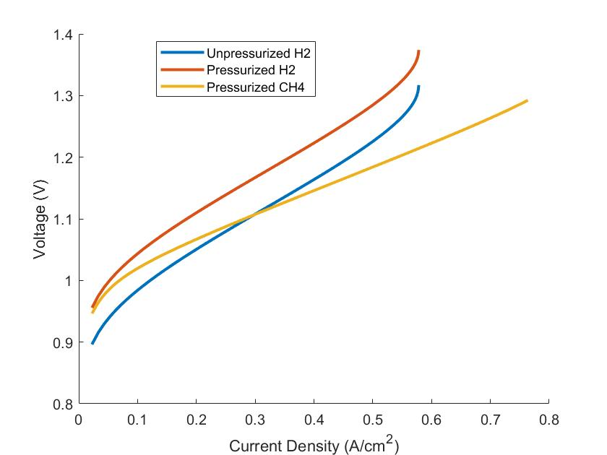

Figure 5.4: reSOFC Voltages in Electrolysis Cell Mode.

Pressurization results in an increased voltage due to changes in the Nernst voltage for the hydrogen-based reSOFC, calculated by equation 5.1. Compared to the hydrogen-based reSOFC, the methane-based reSOFC displays similar voltages at low steam utilizations and lower voltages at higher steam utilizations. Again, this difference between the voltage of the hydrogen-based reSOFC and the CH4-based reSOFC can be attributed to differences in the chemical composition across the reSOFC. Compared to the hydrogen-based reSOFC, the CH4-based reSOFC has a lower molar fraction of hydrogen and an increased molar fraction of H2O due to the methanation and water-gas shift reaction removing hydrogen and generating H2O in the reSOFC cathode. At very low steam utilization rates, the chemical composition within the CH4-based reSOFC is very similar to the hydrogen-based reSOFC. Since the molar fraction of hydrogen is low, the methanation and water-gas shift reaction occur at a low rate. This results in the CH4-based reSOFC and hydrogen-based reSOFC operating at similar voltages at low steam utilizations. At higher steam utilizations, the equilibrium composition within the CH4-based reSOFC contains a significant amount of CH4, resulting in a higher molar fraction of H2O and a lower molar fraction of hydrogen. This results in a more even distribution of hydrogen along the CH4-based reSOFC and a lower voltage. The differences in the chemical composition across the reSOFC between the CH4-based reSOFC and hydrogen-based reSOFC at a single pass steam utilization of 77% can be seen in figure 5.5. The figure on the left shows the chemical composition for a hydrogen-based system and the figure on the right shows the chemical composition for a CH4-based system.

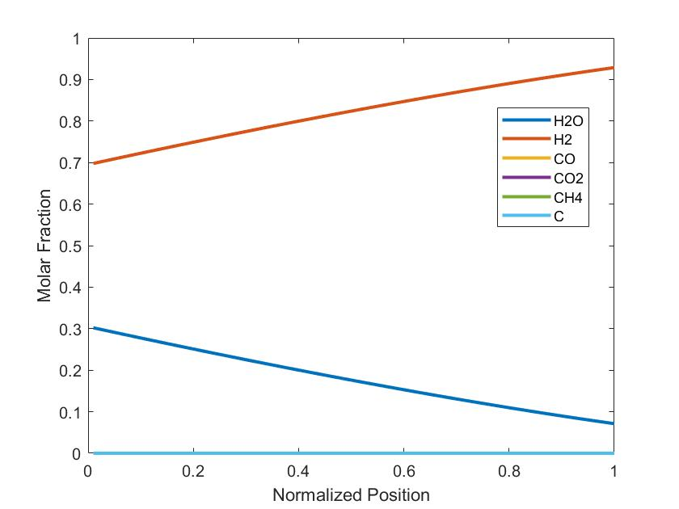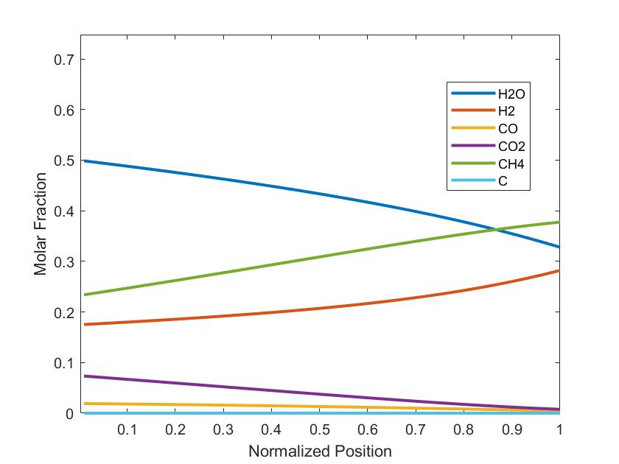

Figure 5.5: Molar Fractions Across reSOFC in Electrolysis Cell Mode.

The methane-based reSOFC has a lower molar fraction of hydrogen and a higher molar fraction of water at all points along the reSOFC anode. One thing to note is that the total flow rate decreases along the length of the reSOFC due to the methanation reaction. That accounts for the seemingly greater increase in the molar fraction of methane than the corresponding decrease in the molar fraction of CO2 would suggest. After the molar fraction of CO2 decreases to the point where methanation is no longer chemically favorable, the rate of methanation decreases and the molar fraction of hydrogen increases at a higher rate. The rate of methanation is dependent on the operating temperature and pressure. Lower operating temperatures and higher pressures would result in an increase in methanation in electrolysis cell mode but also decrease the rate of reformation in fuel cell mode. The molar fraction of carbon is approximately in the methane-based reSOFC, suggesting that the carbon deposition reaction is sufficiently unlikely as to not cause carbon deposition related degradation issues in the described methane-based reSOFC system during electrolysis cell mode.

In electrolysis cell mode, the efficiency of the system is affected by the heat generated from the methanation reaction. This thermal energy decreases the amount of electrical power needed for preheating of reSOFC inlets. The definition for the efficiency of the solid oxide cell, including electrical and thermal power, is given by equation 4.36 and 4.38. These definitions assume that heating requirements from endothermic operation are met through joule heating, but the oxidation-reduction efficiency neglects the reduction in the net enthalpy change from the methanation reaction. A hydrogen-based reSOFC is compared to a methane-based reSOFC in electrolysis cell in figure 5.6 using the same parameters used to generate figure 5.4. Thermoneutral operation is achieved at the current densities where electrical efficiencies drop below 100%.

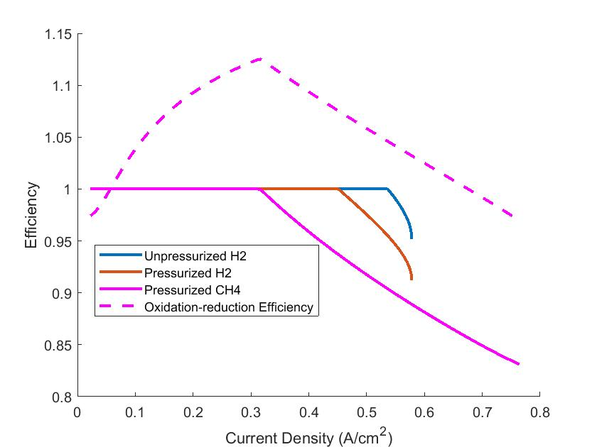

Figure 5.6: Efficiency of the reSOFC in Electrolysis Cell Mode.

At low steam utilizations, the oxidation-reduction reaction in the CH4-based reSOFC has lower efficiency than in the hydrogen-based reSOFC. This is due to hydrogen produced by the CH4-based reSOFC being used by the endothermic water-gas shift reaction to generate CO. This increases the amount of heating needed to maintain thermoneutral operation, decreasing the efficiency of the oxidation-reduction reaction without impacting the electrical efficiency of the reSOFC. At higher steam utilizations, the heat generated by the methanation reaction causes the oxidation-reduction reaction to have an efficiency over 100%. When thermoneutral operation of an electrolysis cell is maintained by the presence of additional heat sources, the efficiency of the oxidation-reduction reaction can exceed 100%. [78]. However, thermoneutral operation results in 100% electrical efficiencies when accounting for changes in the net. In this case, the methanation reaction reduces the molar fraction of hydrogen, increases the molar fraction of H2O, and generates heat within the reSOFC. While the electrical efficiency of the methane-based reSOFC is equal to or lower than that of the hydrogen-based reSOFC, the methane-based reSOFC is able to achieve thermoneutral operation at lower steam utilization rates.

Typically, electrolysis mode in all reSOFC systems would operate at the thermoneutral voltage since that results in an ideal thermodynamic efficiency of 100% [20]. Since thermoneutral operation is achieved at the lowest voltage and current density in the methane-based system, thermoneutral operation of the methane-based reSOFC in electrolysis mode would result in decreased degradation compared to the other systems [79]. A lower thermoneutral voltage results in lower oxygen pumping pressure in the electrolyte, decreasing crack propagation and increasing the life expectancy of the electrolyzer. By controlling the inlet rate of CO2, it may be possible to maintain thermoneutral operation of the reSOFC over a range of current densities.

## System Model Results

Due to the effects of internal methanation and steam reformation, direct comparison of a methane-based reSOFC to a hydrogen-based reSOFC at the same current density is not representative of the actual efficiency of power use and generation. The net change in enthalpy is lower for the same current density, leading to the methane-based system operating at higher current densities to achieve the same power density. To analyze the performance of the system in a way that is more representative of actual use, the efficiency of the system is calculated with a constant reactant utilization rate and a variable reactant flow rate. Since a area of the reSOFC is modeled, results are calculated in terms of the power density.

In fuel cell mode, the inlet flow rate of methane is varied between and and the single pass fuel utilization rate is 70%. The efficiency of the system in fuel cell mode is given by equation 5.4. This corresponds to a net fuel utilization rate of 90.3%.

|  |  |  |
| --- | --- | --- |
|  |  | (5.4) |

Where is the electrical power generated by the reSOFC, is the power used by the balance of plant, is the flow rate of hydrogen, and is the enthalpy of reaction for the oxidation of hydrogen. The net efficiency of the reSOFC system is defined using equation 5.5.

|  |  |  |
| --- | --- | --- |
|  |  | (5.5) |

Where is the rate of hydrogen generation by the HTM.

In electrolysis cell mode, the inlet flow rate of H2O is varied between and . CO2 is fed into the system at a proportion of 0.286 moles CO2 for each mole of H2O and the single pass steam utilization rate is 77%. This is used to achieve the chemical composition shown by figure 5.5 in the previous section of this thesis. The efficiency of the system in electrolysis cell mode is defined by equation 5.6.

|  |  |  |
| --- | --- | --- |
|  |  | (5.6) |

Where is the flow rate of hydrogen out of the system and is the net power used by the system.

### System Overview

Figure 5.7 shows the change in voltage as the reactant flow increases for both fuel cell mode and electrolysis cell mode in a methane-based reSOFC. The left side of the graph describes the electrolysis cell mode while the right side describes fuel cell mode. A positive current density describes power generation while negative power density describes power consumption by the reSOFC component.

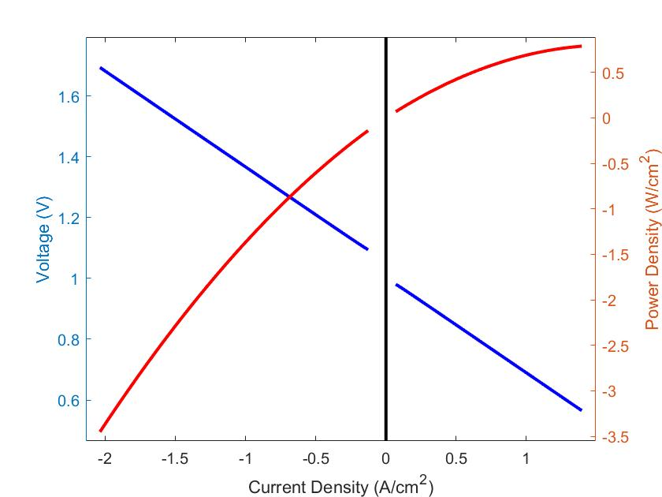

Figure 5.7: Voltage and Power Density of a Methane-based reSOFC.

In fuel cell mode, the voltage decreases with increasing current density. In electrolysis cell mode, the voltage increases with an increased current density magnitude. A shift in the voltage can be seen at low reactant flow between fuel cell mode and electrolysis cell mode due to differences in the chemical composition. The reSOFC has a lower Nernst voltage in fuel cell mode than electrolysis cell mode due to the lower molar fraction of hydrogen. Since the steam reformation reaction is driven by a low molar fraction of hydrogen and the methanation reaction is driven by having a high molar fraction, a higher molar fraction of hydrogen is expected in fuel cell mode than electrolysis cell mode. This can be seen in figures 5.2 and 5.5.

Figure 5.8 shows the electrical efficiency of methane-based reSOFC system in fuel cell and electrolysis cell mode over the previously specified range of reactant flow rates. The electrical efficiency of electrolysis cell mode is shown on the left, and the electrical efficiency and net efficiency of fuel cell mode are shown on the right. The definition for system efficiency, including the impact of the balance of plant, is given by equation 5.4 and 5.6. The definition of the net efficiency of fuel cell mode, including the impact of the HTM, is given by equation 5.5 and is shown by the dashed line.

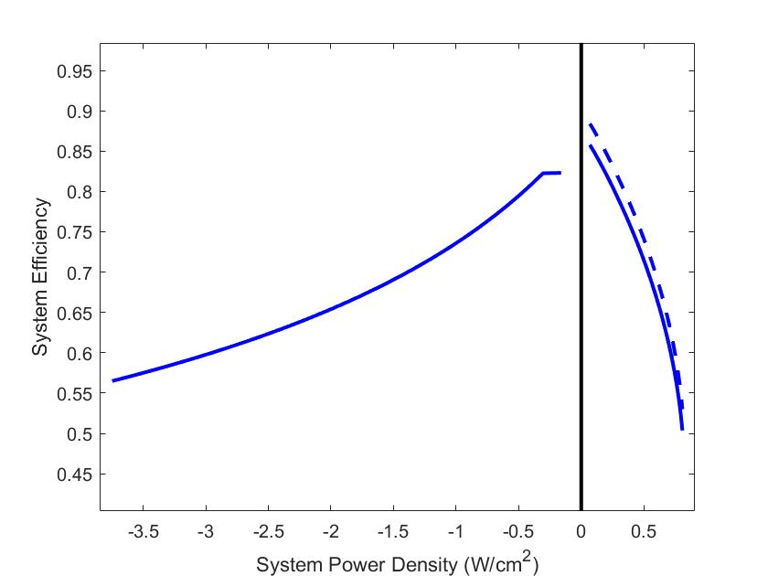

Figure 5.8: Efficiency of a Methane-Based reSOFC System.

In fuel cell mode, the peak efficiency was found to be 86.1% at a system power density of 0.069 and efficiency decreases with increased reactant flow rates. In electrolysis cell mode, the peak efficiency was found to be 82.3% at a system power density of 0.16 and efficiency decreases with increased reactant flow rates. The apparent difference in behavior between electrolysis cell mode and fuel cell mode in figure 5.8 can be attributed to the differences between power generation and power consumption. Inefficiency in power generation causes reduced power generation, meaning lower power densities, while inefficiency in power consumption causes additional power consumption, resulting in more negative power densities. At low reactant flow rates, the system efficiency of the reSOFC system in electrolysis cell mode is constant. This is due to the reSOFC not generating enough waste heat to fully preheat the inlet flow and unmet heating demand being met by joule heating.

### Comparison to Hydrogen-based reSOFC

Figure 5.9 compares the efficiency of a methane and hydrogen-based reSOFC over a range of system power densities. The electrical efficiency for both reSOFC systems is defined by equation 5.4 in fuel cell mode and 5.6 in electrolysis cell mode. The figure is generated using the same parameters used to generate figure 5.8 for the methane-based system. The hydrogen-based system is fed pure hydrogen at a rate equivalent to complete reformation in the methane-based system in fuel cell mode. Overall, the methane-based reSOFC achieves higher electrical efficiencies in fuel cell mode and lower electrical efficiencies in electrolysis cell mode compared to a hydrogen-based reSOFC at the same power density. This is consistent with results in the literature [24].

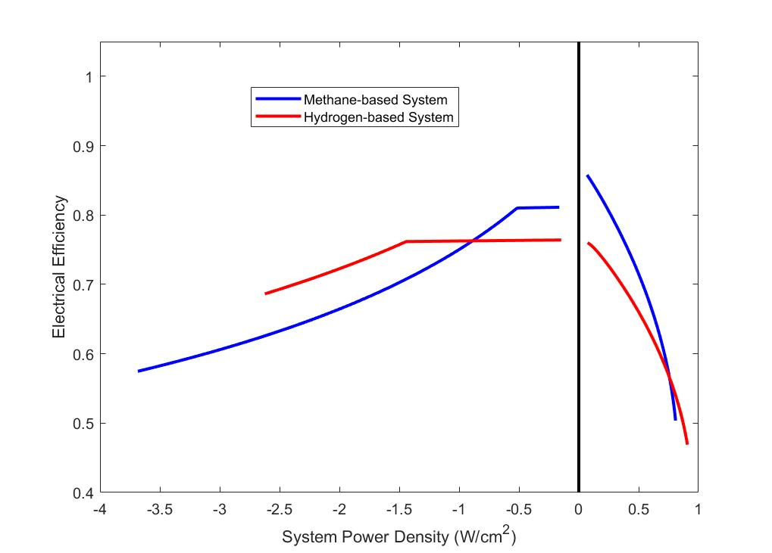

Figure 5.9: System Efficiency vs System Power Density of Methane and Hydrogen-based reSOFC

At low power densities in electrolysis cell mode, the methane-based reSOFC displays higher electrical efficiencies than the hydrogen-based system. This is caused by the methane-based reSOFC having lower heating requirements to maintain thermoneutral operation due to heating from internal methanation and steam generated by the methanation reaction. At the same inlet flow rate of steam and steam utilization rate, the methane-based system operates at a 42% higher current density. This effectively reduces the amount of Joule heating done by the system at low power densities, resulting in a greater electrical efficiency at low power densities due to lower electrical losses to the balance of plant. These results are consistent with the literature [80]. As the power density of the system increases, the amount of heat generated by the hydrogen-based reSOFC increases and replaces Joule heating, resulting in no change in system efficiency at low power densities. At higher power densities, the methane-based system is less efficient than the hydrogen-based system. The methane-based reSOFC has to operate at higher current densities than the hydrogen-based reSOFC, resulting in increased ohmic losses and concentration losses within the reSOFC. At high power densities, where additional waste heat is no longer usable, this results in a significant reduction in the electrical performance of the system.

In fuel cell mode, the methane-based system displays a higher efficiency than a hydrogen-based system at low power densities. Heat is absorbed by the steam reformation reaction, leading to a greater percentage of the net change in enthalpy being converted into electrical power. At higher power densities, the hydrogen-based reSOFC has higher electrical efficiency than the methane-based reSOFC due to parasitic loses from the balance of plant. Since the methane-based system has to pressurize exhaust for underground storage, it is subject to additional electrical losses from the balance of plant compared to the hydrogen-based system. Additionally, the methane-based reSOFC has to operate at higher current densities in order to achieve the same power density as the hydrogen-based system. This causes increased resistive loses compared to a hydrogen-based system.

### HTM Analysis

To characterize the impact of the installation of an HTM on the efficiency of a methane-based reSOFC in fuel cell mode and optimize the results, the reSOFC is run at a single pass fuel utilization rate of 70%, an anode exhaust recirculation rate of 75%, and a fuel flow rate of . This results in a current density of . The pressure of the hydrogen stream of the HTM is then varied from 0 to 200 kPa and the efficiency of the system, including hydrogen production, is recorded. In this way, the rate of hydrogen recovery is varied, and the optimal rate of hydrogen recovery can be found. Here the effective flow rate of hydrogen into the system, , is calculated assuming a complete conversion of methane to hydrogen. Figure 5.7 shows the change in the net efficiency of the system, calculated using equation 5.5 over varied permeate stream pressures.

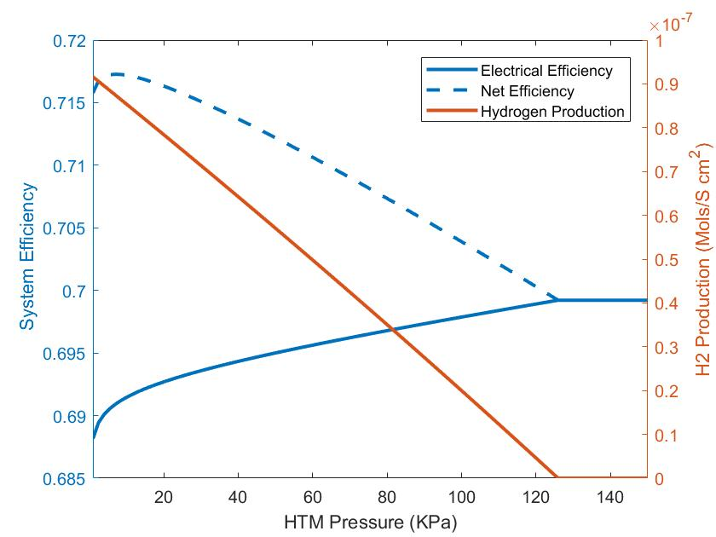

Figure 5.10: Impact of HTM on System Efficiency

The electrical efficiency increases as the pressure of the HTM permeate flow increases until the point where hydrogen coproduction ceases. This decrease in electrical efficiency with increased hydrogen production is caused by an increase in power used by the balance of plant and a decrease in the amount of power that can be produced by the turbine. Since the oxidizer heats up the exhaust stream of the reSOFC by oxidizing unused fuel, the turbine inlet temperature decreases when hydrogen is removed from the reSOFC exhaust stream. This results in a decrease in the amount of power that can be produced by the turbine. At low HTM pressures, there is a higher decrease in the electrical efficiency of the system due to an increase in compressor power usage. Since hydrogen produced by the system must be compressed up to 700 bar, a low pressure on the hydrogen side of the HTM results in the hydrogen production stream needing to be compressed over a large pressure ratio. This results in high compressor power use and a larger decrease in the net efficiency of the system.

While the net efficiency of the system is highest when hydrogen is produced with an HTM pressure of 5 kPa, the increase in net efficiency from using the HTM is only around 1.7%. Since the system has a net fuel utilization rate of 90.3% and a portion of unused fuel is in the form of , hydrogen flow across the HTM is limited by the low partial pressure of hydrogen in the reSOFC exhaust stream. Small increases in the partial pressure of hydrogen could be accomplished by decreasing the fuel utilization rate, however large increases would require more significant changes to the reSOFC system.

# reSOFC Energy Storage Methodology

In this section, the methodology used to compare the use of a reSOFC-based energy storage system to other strategies for increasing renewable integration is shown. For each strategy discussed in this thesis, including reSOFC-based energy storage, battery energy storage, and curtailment, a separate system model is created that simulates the performance of that strategy in the Pacific Northwest region over the lifetime of the system. This is accomplished by using a year of data with intervals every 5 minutes, starting on January 1st and ending on December 31st. It is assumed that this year is representative of the performance of the system over its lifetime. These models are used to calculate system properties for a specified installed capacity of wind power, solar power, and any energy storage if applicable.

## Model Creation

The performance of each strategy is evaluated through the levelized cost of electricity (LCOE) for a given renewable energy penetration rate. The LCOE is found using equation 6.1.

|  |  |  |
| --- | --- | --- |
|  |  | (6.1) |

Where is the initial cost, is the operation and maintenance cost, is the energy demand met by the system in year , is the discount rate, and is the degradation rate. The discount rate is assumed to be 5.6% [81]. A method for calculating the LCOE for a combination of wind, solar, and energy storage is given by equation 6.2.

|  |  |  |
| --- | --- | --- |
|  |  | (6.2) |

Where is the LCOE of a component that provides energy and is the total amount of energy produced by the system.

Demand and wind power profiles are created using data supplied, in 5-minute intervals, by the Bonneville Power Authority for the year 2015 [82]. Solar power profiles are created using data supplied by the National Renewable Energy Lab, in 5-minute intervals, for utility-scale solar power plants in the state of Washington [83]. Solar power profiles were provided for specific utility scale solar generators, so a generic power profile was created by summing the power generation for each utility scale generators in the data set. Solar power data is sourced from 20 utility scale sites and wind power data is sourced from all wind power sites in the BPA region, resulting in a degree of spatial averaging. Demand profiles are used without alteration, but wind and solar power profiles need to be sized based on the desired installed capacity of wind and solar power. To accomplish this, the total amount of energy generated in the yearly demand data is calculated in MWh using equation 6.3.

|  |  |  |
| --- | --- | --- |
|  |  | (6.3) |

Where is the rate of power generation. To normalize the renewable power generation profiles, the energy production over each timestep is calculated using equation 6.4.

|  |  |  |
| --- | --- | --- |
|  |  | (6.4) |

These normalized energy generation profiles can then be scaled up to the desired amount of wind and solar power in MW using the definition of the capacity factor.

The capacity factor, measuring the average percentage of the installed capacity that is generated over a year, is given by equation 6.5.

|  |  |  |
| --- | --- | --- |
|  |  | (6.5) |

Where is the power generated as a function of time and is the installed capacity in MW, or nameplate capacity. The LCOE for variable renewable generators coming online in 2020 is for onshore wind power and for solar PV on average [81]. Since these values are based on national averages, some regions may be able to achieve lower LCOE than these values. These LCOE values are calculated assuming a capacity factor of 37% for onshore wind and a capacity factor of 26% for solar PV and do not include the effects of curtailment. In Washington state, these values are approximately 32% for wind power [84] and 18% for solar power [85]. To calculate the LCOE cost of wind and solar power in the pacific northwest, these values are adjusted using equation 6.6.

|  |  |  |
| --- | --- | --- |
|  |  | (6.6) |

Where is the capacity factor at which the LCOE value was calculated, and is the capacity factor of the adjusted LCOE value. This results in LCOE values of approximately for onshore wind power and for solar PV in the Pacific Northwest.

At each timestep, the total electrical power demand must be met through a combination of renewable power, conventional generators, and any installed energy storage systems. This is expressed by equation 6.7.

|  |  |  |
| --- | --- | --- |
|  |  | (6.7) |

Where is the power generated by base load generation, is the power generated by conventional generation that may be curtailed, is the power generated by wind and solar power, and is the power generated by energy storage devices. Any excess renewable power that cannot be used to meet demand or be stored in energy storage is curtailed. Conventional generators, used to meet demand unmet by renewable power and energy storage, have a minimum operating point, represented by the base load generation term.

The annual renewable energy penetration, describing the percentage of the total electrical demand met through renewable energy, is defined by equation 6.8.

|  |  |  |
| --- | --- | --- |
|  |  | (6.8) |

While some use the annual renewable penetration as a measure of the total amount of renewable generation, widespread energy storage use and curtailment at high annual renewable penetration rates result in a significant difference between the amount of renewable power generated and the demand that is met by renewable power. As such, this definition does not include the power used by energy storage devices and is consistent with how this term is used in the literature [7] [86] [87]. Due to differences in the generation profiles of wind and solar power, the annual renewable penetration is dependent on the composition as well as the installed capacity. In this thesis, the solar capacity fraction is defined as the percentage of renewable generation that comes from solar power, shown by equation 6.9.

|  |  |  |
| --- | --- | --- |
|  |  | (6.9) |

Where is the total amount of energy generated by solar power and is the total amount of energy generated by wind power. Due to differences in cost and availability, the optimal installed capacities of wind and solar power changes with increases to the annual renewable energy penetration. For a given strategy, the optimal mixture of wind and solar power can be described in terms of the solar capacity fraction.

In this thesis, it is assumed that conventional base load generation provides 50% of the total annual generation. This means that the maximum achievable annual renewable energy penetration is 50%. For the Pacific Northwest region, this is 26,900 GWh over the whole year, or an average of 3070 MW. This is shown by figure 6.1.

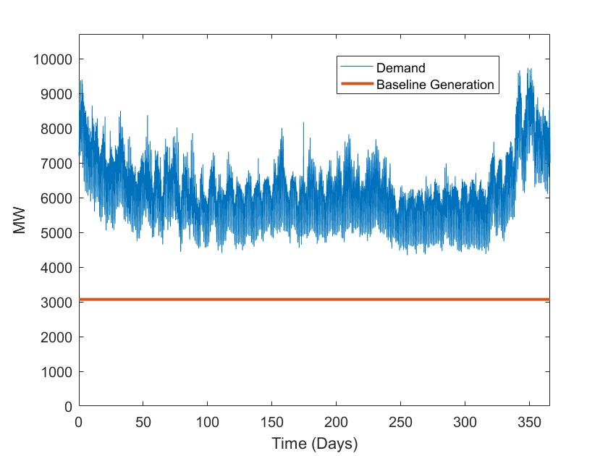

Figure 6.1: Yearly Demand Profile and Baseline Generation Limit

Due to the chosen start and end dates of the simulation, the beginning and end of the graphs are during winter and the middle is during the summer. The choice using demand data from the Pacific Northwest results in increased demand during winter compared to spring, summer, and fall, due to heating demand. This means seasonal energy storage plays a significant role in the cost effectiveness of the system at high annual renewable energy penetrations, due to seasonal variation in wind and solar power. Selection of demand data from other locations could result in different demand profile characteristics.

Energy storage use profiles are generated based on the assumption that use of renewable power to meet demand is prioritized over use of renewable power for use by energy storage or use of stored energy to meet demand. At each timestep, this can be represented by equation 6.10.

|  |  |  |
| --- | --- | --- |
|  |  | (6.10) |

When the value of is positive, energy storage can be used to meet demand. When the value is negative, renewable energy is used to store power in the energy storage device. The amount of energy in the energy storage system can then be described by equation 6.11 when energy storage is being used to meet demand and 6.12 when power is being stored.

|  |  |  |
| --- | --- | --- |
|  |  | (6.11) |
|  |  | (6.12) |

Where is the energy stored in the energy storage system, is the electrical efficiency of the energy storage system, and is 5 minutes.

In order to calculate system properties that are more representative of the performance of the system over its lifetime, these models calculate the system performance past the first year of operation. This means that energy storage use profiles generated with this method may start with some energy already stored. For example, a reSOFC-based energy storage system would have methane stored in the methane storage cavern. This can be seen in figure 6.2.

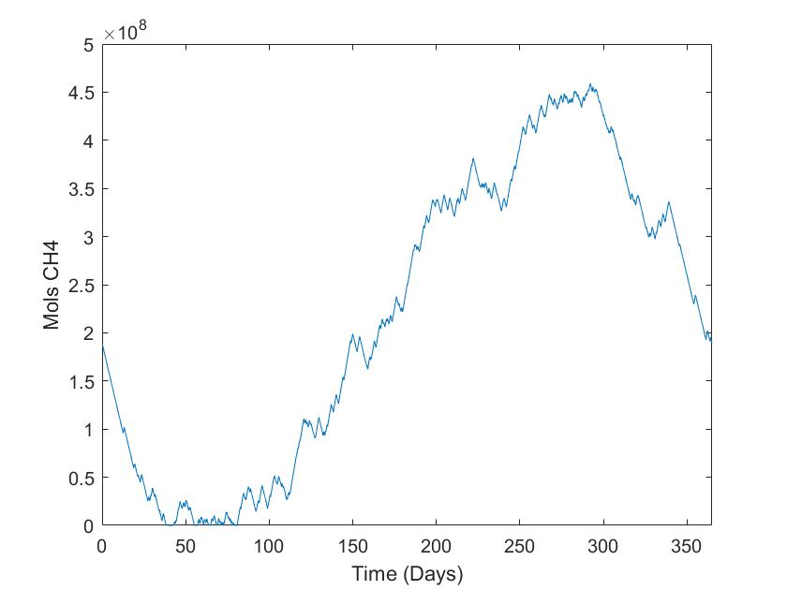

Figure 6.2: Potential Energy Storage Profile for a reSOFC-based Energy Storage System

Since it is assumed that these systems operate cyclically, with use profiles being the same every year, this results in the power stored at the beginning of the year being the same as the power stored at the end of the year.

### reSOFC-based Energy Storage Model

In this model, the efficiency changes over time depending on the power output of the reSOFC system. The efficiency of the reSOFC system at each time step is calculated using an efficiency curve generated by the reSOFC system model discussed in section 4 and 5 of this thesis. Many parameters governing the operation and cost of reSOFC-based energy storage are taken from the Department of Energy technical targets for stationary fuel cell applications [7]. In this model it is assumed that the operating lifetime of a reSOFC is 80,000 hours, that the system availability is 99%, and that the degradation rate is 0.3% per 1,000 hours. At a 99% uptime and 80,000-hour lifetime, constant use results in a lifetime of approximately 9 years.

In the reSOFC-based energy storage model, the system power density is limited to ensure high round trip efficiencies. This is accomplished by limiting fuel cell mode to a system power density of and electrolysis cell mode to , resulting in a minimum roundtrip efficiency of 50%. This corresponds to current densities of approximately in fuel cell cell mode and in electrolysis cell mode. This would increase the durability of the reSOFC component [88] at the expense of increasing the installation cost of the system. In practice, lower power densities limits may be necessary in order to reach the rate of degradation in the DOE technical targets for stationary fuel cells.

The cost of the system is taken from the literature and estimated to be approximately depending on the size of the underground storage and water reservoir [89] [46]. Due to potential unknowns in the cost of the reSOFC system, a safety factor of 100% is used, bringing the total cost to approximately . Operation and maintenance costs are not widely available for reSOFC. In fuel cell mode, they are assumed to be in fuel cell mode [90] based on maintenance costs of similar fuel cell technologies. In electrolysis cell mode, they are estimated to be approximately , calculated from the maintenance cost per kg of H2 in DOE technical targets for centralized hydrogen production from electrolysis using solid oxide electrolysis cells [91].

Due to the yearly energy storage profile generated using equation 6.10 potentially resulting in more methane being stored than could be used, the methane storage cavern and water reservoir are optimally sized to prevent excess energy storage. This is accomplished by simulating the performance of the energy storage system for four years. First, the performance of the system is calculated for two sequential years using the use profile generated from equation 6.10 without any limitations on the size of the methane storage cavern. If the methane stored in the methane cavern at the end of the second year is higher than at the end of the first year, subsequent years will also result in a net increase in the methane stored in the methane storage cavern. This means that the use profile generated from equation 6.10 will not result in cyclical operation. When this condition occurs, the methane cavern is sized using equation 6.13.

|  |  |  |
| --- | --- | --- |
|  |  | (6.13) |

Where is the amount of methane in the cavern at the end of year 1, is the amount of methane in the cavern at the end of year two and is the maximum amount of methane in the cavern during year 1. Then the performance of the system is modeled again with the limit on the size of the methane storage cavern found using equation 6.13. When the limit on methane storage is reached and renewable power is available, the reSOFC system is used to generate hydrogen through steam electrolysis and is sold at the rate of $2/gge along with the hydrogen generated by the HTM in fuel cell mode. This scenario is shown by figure 6.3.

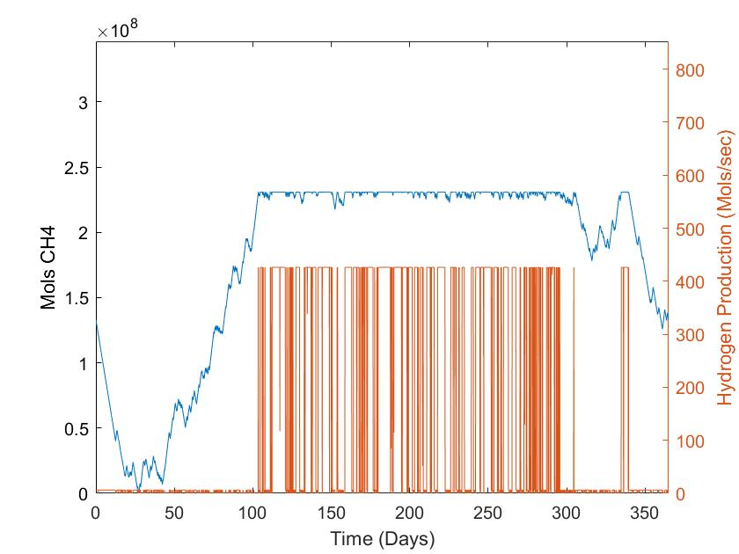

Figure 6.3: Methane Storage and Hydrogen Production for reSOFC-based Energy Storage System

This plot was calculated under conditions where more renewable power was available to the reSOFC system than could be used to meet demand. This causes the methane storage to be limited to the value calculated by equation 6.9, creating a plateau during times of high renewable energy availability. When this occurs, hydrogen is produced by the system through electrolysis. During other times of the year, the hydrogen production rate can be attributed to hydrogen recovery from the HTM. The net efficiency of the reSOFC-based energy storage system, ignoring power used for hydrogen production through electrolysis, is defined using equation 6.14.

|  |  |  |
| --- | --- | --- |
|  |  | (6.14) |

Where is the total energy demand met by the reSOFC system and is the total energy used to store methane.

### Battery Energy Storage Model

This thesis uses a simple model of a lithium-ion based battery energy storage system to serve as a comparison to the reSOFC-based energy storage system. Lithium-ion batteries are known to have desirable properties for an energy storage system, including high efficiency and a low self-discharge rate [92]. Due to differences in the underlying function of the battery compared to the rSOFC, the model for the battery energy storage system has unique properties that are addressed in this section. The maximum charge/discharge rate is limited to , meaning that the the maximum capacity can be discharged over one hour. This limits the degradation rate of the system [93]. The rate of self-discharge is given by equation 6.15.

|  |  |  |
| --- | --- | --- |
|  |  | (6.15) |

Where is the energy stored within the battery, is 5 minutes, and is the self-discharge rate, assumed to be [94]. The energy balance of the system with self-discharge is given by equation 6.16 when generating power and equation 6.17 when storing power.

|  |  |  |
| --- | --- | --- |
|  |  | (6.16) |
|  |  | (6.17) |

Where is the efficiency of the battery, and is the power use calculated using equation 6.10. The efficiency of the battery when charging or discharging is 90%, resulting in a roundtrip efficiency of 81% if losses from self-discharge are neglected [95]. The battery energy storage system is assumed to have a cost of $250 per kWh of capacity including the cost supporting equipment, a 10-year lifetime, have a degradation rate of 1% per year, and operation and maintenance costs of [96] [97].

## Model Comparison Methodology

The strategies of curtailment, battery energy storage, and rSOFC-based energy storage will be compared by determining the LCOE, annual renewable energy penetration, and other properties when meeting a specified energy demand profile with a mix of wind and solar power. For each combination of installed capacities of wind and solar power, the optimal sizing of energy storage is found through a derivative based search method. This process optimizes for maximum annual renewable energy penetration constrained with a maximum LCOE found with no energy storage. This problem can be solved using equation 6.18.

|  |  |  |
| --- | --- | --- |
|  |  | (6.18) |

Where is the LCOE without energy storage installed, is the annual renewable energy penetration without energy storage installed, is the LCOE for a selected installed capacity of energy storage, and is the annual renewable energy penetration for a selected installed capacity of energy storage. By increasing the installed capacity of energy storage until the value calculated by equation 6.18 is greater than zero, the annual renewable energy penetration is maximized without increasing the LCOE of the system.

Optimizing for minimal LCOE at specific installed capacities of wind and solar power independently results in higher LCOE for a given annual renewable energy penetration than optimizing penetration as discussed. This is shown by figure 6.4.

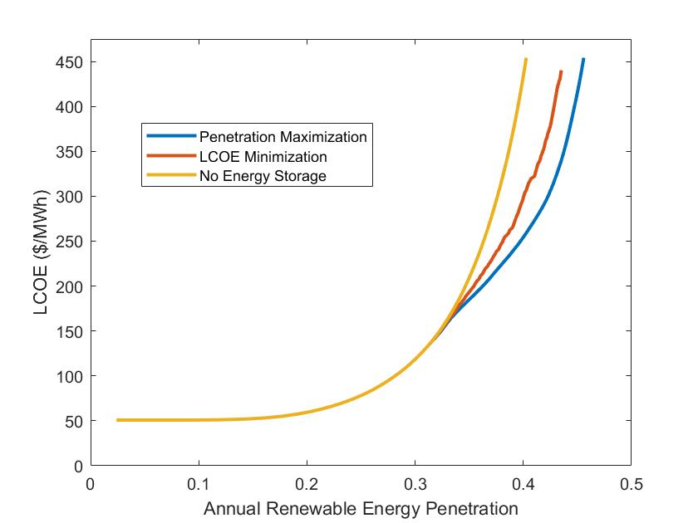

Figure 6.4: Comparison of Optimization Methods Using Wind Power and Battery Energy Storage

This figure is created by calculating the LCOE over a range of installed capacities of wind power using two methods to size the battery energy storage system. The LCOE is also calculated without energy storage over the same range of installed capacities of wind power to serve as a point of comparison. The sizing of battery energy storage is calculated using the previously discussed penetration maximization method and a LCOE minimization method, which selects the energy storage sizing that results in the lowest LCOE of all power generated using equation 6.2. Since the penetration maximization method was found to achieve higher annual renewable energy penetrations for the same LCOE than the LCOE minimization method and the change in LCOE with increasing penetration is continuous, this suggests that the penetration maximization method results in optimal sizing of energy storage devices for a given installed capacity of renewable power.

A grid-based search method is used to characterize system properties with optimal sizing over a range of installed capacities of renewable power and solar capacity fractions. Each node on the grid is assigned an installed capacity of renewable power and solar capacity fraction, and system properties are calculated using the previously discussed penetration maximization method. Since changes in the solar capacity fraction result in changes in the LCOE and annual renewable energy penetration, the optimal configuration is found by selecting nodes that do not decrease the annual renewable energy penetration and result in the lowest slope, calculated using equation 6.19.

|  |  |  |
| --- | --- | --- |
|  |  | (6.19) |

Where is the LCOE at the previously selected node, is the annual renewable energy penetration at the previously selected node, is the LCOE at the selected node, and is the penetration at the selected node. By iteratively selecting nodes using this method, the optimal configuration and system properties are found over a range of annual renewable energy penetrations. This method does not prevent the installed capacity of wind power, solar power, or energy storage from decreasing with increased installed capacities of renewable power. When this occurs, large changes in the system properties, such as the LCOE or annual renewable energy penetration, can result.

# reSOFC Energy Storage R**esults**

In this section, strategies of curtailment, use of battery energy storage, and reSOFC-based energy storage are compared using the methodology found in section 6 of this thesis. As curtailment causes high annual renewable penetrations to be economically infeasible [7], curtailment is used as a baseline in comparing the performance of battery energy storage and reSOFC-based energy storage. Without the use of energy storage, all excess renewable energy must be curtailed. When this occurs, the LCOE of the system increases exponentially with increases in the annual renewable energy penetration. This can be seen in figure 7.1.

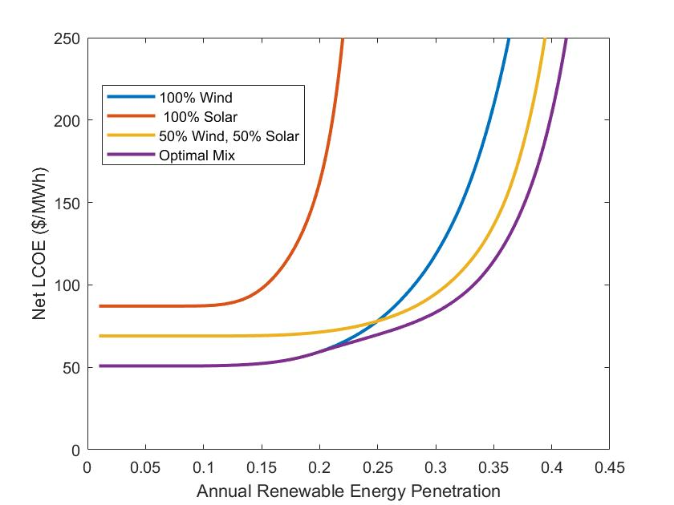

Figure 7.1: Economic Performance of the Curtailment Strategy

Once renewable energy starts to be curtailed, the portion of renewable power that is not curtailed decreases with increased installed capacity of renewable power. This causes the LCOE of the system to rise at an increasing rate with increased annual renewable energy penetration. Since the distribution of renewable power generation over the year is a function of the solar capacity fraction, the optimal and 50% wind, 50% solar mixtures have a slower rate of increase in the LCOE as annual renewable energy penetrations increase. The difference in LCOE between wind and solar power can be attributed to the lower cost of generation in Washington state and lower rate of curtailment at the same annual renewable energy penetration. Under the optimal configuration, the addition of some solar generation can lower the net LCOE at penetrations above 19% by consistently providing power coincident with the mid-day peak energy demand.

The optimal solar capacity fraction changes as the amount of demand that can be filled decreases with increased annual renewable energy penetration. This can be seen by figure 7.2.

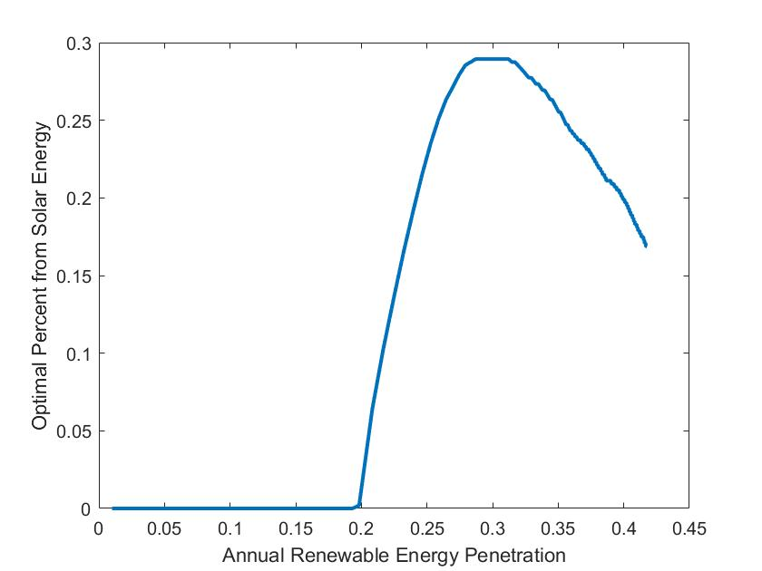

Figure 7.2: Optimal Solar Capacity Fraction Using Curtailment

The optimal solar capacity fraction ranges from 0 to 27%, meaning that the system is mostly powered by wind energy in optimal configurations. At low annual renewable energy penetrations, the system is entirely powered by wind due to the low LCOE of wind power. Once curtailment of wind power occurs, it becomes more cost effective to include some solar generation. Differences between the power generation profiles of wind and solar power result in decreased curtailment when wind and solar power are mixed. At higher renewable energy penetrations, portions of both the wind and solar power have hit the limits imposed by baseline generators. Due to wind power having a lower LCOE and a more evenly distributed power generation profile, increasing the installed capacity of wind power results in a larger increase in the annual renewable energy penetration for the same increase in LCOE at high annual renewable energy penetrations. This causes a decrease in the optimal solar capacity fraction at high renewable energy penetrations.

## Battery Energy Storage

Battery energy storage is subject to factors that change the optimal solar capacity fraction, including a high cost of storage per MWh of capacity and self-discharge. These result in a change in the optimal configuration of the system compared to a system solely using curtailment. This can be seen in figure 7.3.

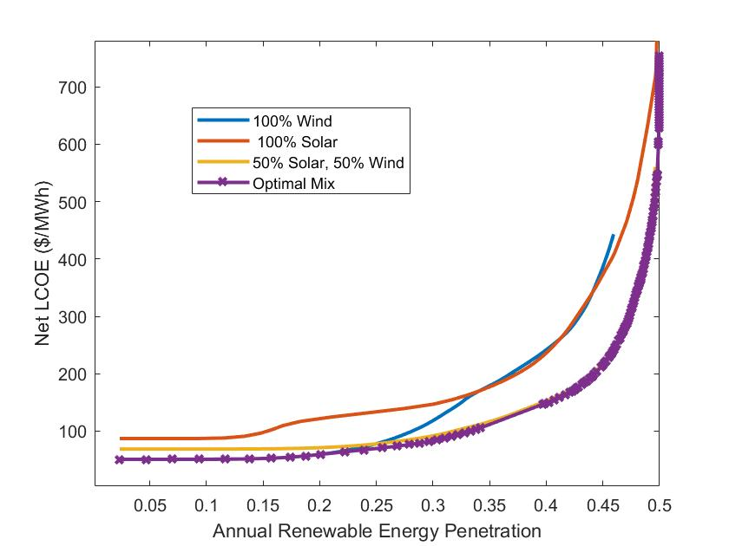

Figure 7.3: Economic Performance of the Battery Energy Storage Strategy

When using a battery energy storage system, wind power still has the lowest LCOE at low annual renewable energy penetrations where battery storage is unused. This is due to the relatively high cost of solar power in Pacific Northwest. At higher annual renewable energy penetrations, use of 100% wind power has a similar cost to 100% solar power. This results from the high cost per MWh of storage capacity for battery energy storage, which are better suited to the diurnal energy storage requirements of solar power. Wind often requires multi-day or even weeklong energy storage. Battery storage has a high maximum charge/discharge rate relative to the energy storage capacity, which complements the consistent cycling shown by the solar power profile. With solar power, the battery is able to consistently charge during the day and then discharge at night. This results in the optimal configuration of the battery energy storage system satisfying a larger portion of demand with solar power than wind power. This is consistent with the results of studies on implementation of battery energy storage in other regions [98] [7]. This can be seen by figure 7.4.

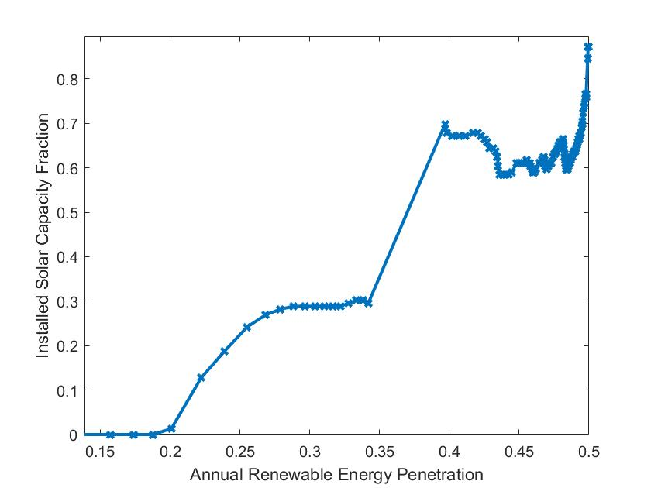

Figure 7.4: Optimal Solar Capacity Fraction Using Battery Energy Storage

An interesting feature of figure 7.4 is the discontinuity occurring from 35% to 40% annual renewable energy penetration. This results from a modal change in configuration where the use of battery energy storage becomes cost effective and the optimal configuration changes to use battery energy storage. The compatibility of batteries with the diurnal solar profile results in a sudden change in the optimal solar capacity fraction from 30% to 70% as the installed capacity of renewable power increase from 13.4 GW to 13.8 GW. These types of nonlinearities make design of incentive programs difficult, as the transition from curtailment to battery energy storage results in no easily identifiable transition period in the Pacific Northwest.

While studying the optimal configuration is straightforward, progressing from the current state of renewable generation along an optimal path of growth is difficult. The large change in the optimal system configuration makes following the optimal solar capacity fraction while increasing the annual renewable energy penetration problematic. Due to the rapid change in configuration, slowly increasing the renewable energy penetration by increasing the installed capacity of renewable power and energy storage requires deviation from the optimal capacity fraction during the transition from curtailment to battery energy storage. Increasing the installation of solar power at low renewable energy penetrations to be constituent with the optimal result at high renewable energy penetrations results in a higher LCOE at low annual renewable energy penetrations, while increased installation of wind power at high annual renewable energy penetrations results in a higher LCOE at higher annual renewable energy penetrations.

## reSOFC-based Energy Storage

Compared to battery energy storage, the cost of storage capacity per MWh is significantly lower due to the low cost of underground storage caverns. This results in wind power being more competitive with reSOFC-based energy storage systems. This can be seen in figure 7.5, which shows the optimal LCOE of a reSOFC-based energy storage system at different mixtures of wind and solar power.

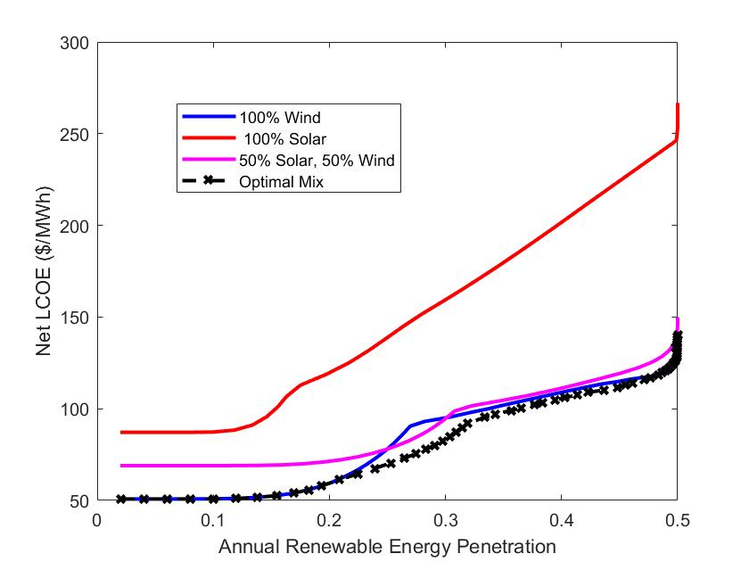

Figure 7.5: Economic Performance of the reSOFC-based Energy Storage Strategy

Like in the curtailment-based system, the LCOE of a purely wind powered system is lower than in a purely solar powered system at all renewable energy penetrations. Additionally, the LCOE of a reSOFC-based energy storage system increases dramatically at renewable energy penetrations very close to 50%. This suggests that the synergistic effect of the daily cycling of the solar power profile on battery-based storage is not present in reSOFC-based energy storage. This is due to the de-coupling of the maximum energy storage capacity (MWh) and maximum power generation and storage rate (MW) in a reSOFC-based energy storage system.

The methane storage cavern can be sized independently of the size of the reSOFC system. Since increasing the size of an underground storage cavern is significantly less expensive than increasing battery capacity, it is less expensive for a reSOFC-based energy storage system to address variation in power demand and renewable generation. This allows the reSOFC-based energy storage system to store power for longer periods of time before use, resulting in an increase in the use of more wind power. It is more cost effective for the reSOFC-based energy storage system to store wind power over long periods of time than to use solar power, which would require cycling of the methane storage cavern.

Another factor in the relatively low LCOE of the reSOFC-based energy storage system is the revenue from the sale of hydrogen. While relatively small compared to the total system cost, hydrogen generated by the system results in a reduction in the LCOE. At 50% annual renewable energy penetration, the sale of hydrogen results in revenue of $1.8 billion dollars per year. This results in a maximum reduction of the LCOE of . While this is a significant reduction in the LCOE, most of the hydrogen produced by the system is generated from steam electrolysis. Hydrogen generated by the HTM accounts for 1.8% of total hydrogen generation. This suggests that use of an HTM results in a relatively small change in the LCOE and may not be economically viable. An important thing to note is that there are no large gaps between data points on this figure, meaning that the change in cost of the optimal system configuration is gradual as the renewable energy penetration increases.

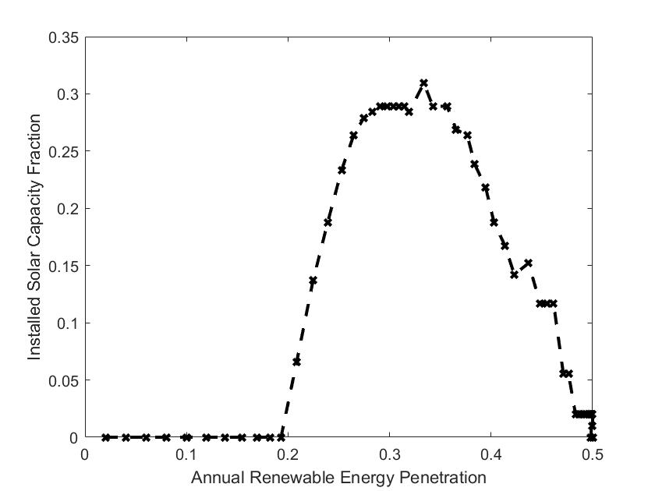

Figure 7.6: Optimal Solar Capacity Fraction Using reSOFC-based Energy Storage

The optimal solar capacity fraction rises to 30% before gradually decreasing down to zero. As the annual renewable energy penetration increases, the amount of annual renewable energy penetration that is from energy storage increases. This incentivizes the use of cheaper wind power. At annual renewable energy penetration rates of 30%, it is cheaper to use solar than to use energy storage to meet the same portion of the demand profile due to spikes in the demand profile during the day. At 50% annual renewable energy penetration, a large portion of the demand profile is met by energy storage. This necessitates a large installed capacity of reSOFC-based energy storage, making it less difficult for spikes in the demand profile that cannot be met by wind power to be met by energy storage.

One way that the reSOFC-based energy storage system is able to achieve low LCOE at high annual renewable energy penetrations is through the efficiency of the system increasing with additional size. This can be seen in figure 7.7.

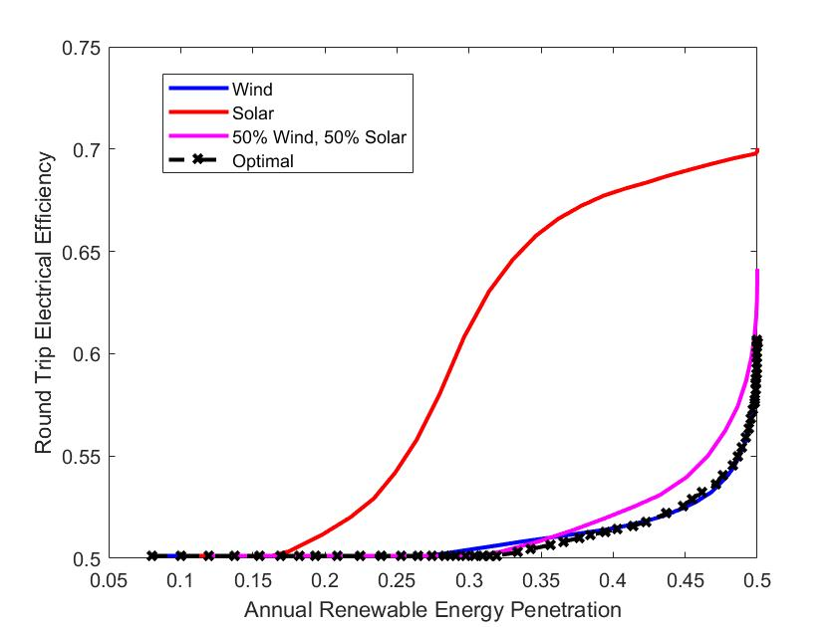

Figure 7.7: Roundtrip Efficiency of reSOFC-based Energy Storage System

Due to the way the reSOFC-based energy storage system was sized, all installed capacities of renewable power were equipped with some energy storage. At low annual renewable energy penetrations, this sizing is infinitesimally small and results in the minimum roundtrip efficiency of 50%. At higher annual renewable energy penetrations, the roundtrip efficiency increases towards the maximum efficiency of 70%. The maximum efficiency is high due to the average power density dropping to near zero when using solar power. A more representative maximum roundtrip efficiency of 60% is seen in the case of the optimally configured system. This value is consistent with results in the literature for reSOFC-based energy storage systems with internal reformation [73]. Due to the use of constant compressor and turbine efficiencies and neglection of thermal losses to the environment, these should be considered an upper limit to efficiencies achievable with a real system.

## LCOE Comparison

Compared to battery energy storage, reSOFC-based energy storage was found to be able to achieve lower LCOE over a wide range of annual renewable energy penetrations. This is shown by figure 7.7.

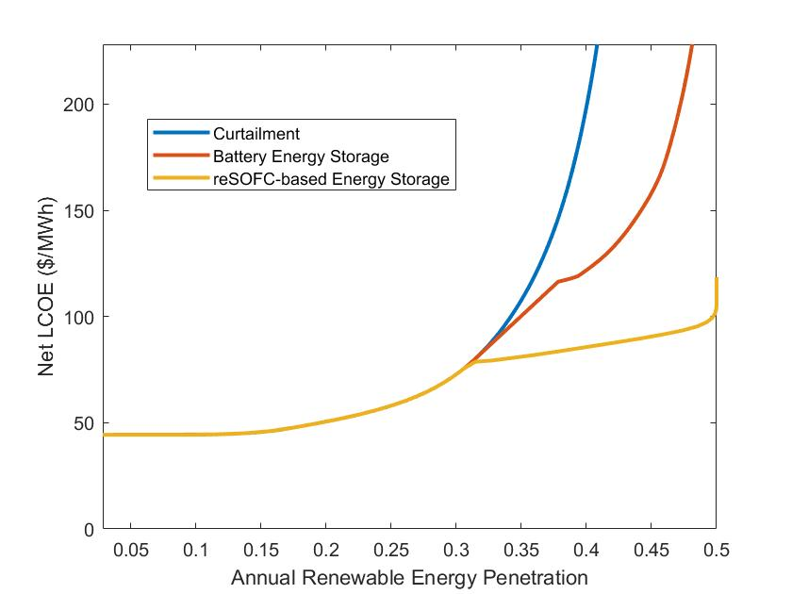

Figure 7.8: LCOE Comparison of reSOFC-based Energy Storage and Battery Energy Storage

While this suggests that reSOFC-based energy storage may be a viable competitor to battery energy storage in the Pacific Northwest in increasing renewable penetration, the use of reSOFC-based energy storage at this LCOE requires further development on reSOFC technology. Not only would a reSOFC-based energy storage system require new technical developments to meet technical projections for SOFC technology that may require substantial research to solve [90], but reSOFC have unique durability issues that may impact attainable system costs, power densities, and degradation rates [99]. The results shown here suggest that the viability of reSOFC-based energy storage should be further investigated.

# Conclusion

In order to increase the amount of renewable energy used by utilities in the Pacific Northwest, the performance of a reSOFC-based energy storage system in increasing the renewable energy penetration was characterized. To improve the performance of the system compared to other reSOFC-based energy storage system designs in the literature, internal reformation and hydrogen transport membrane. This thesis has shows that these design characteristics result in an overall improvement of the performance of the system through the use of a component level steady state system model. The following results were found with the reSOFC-based energy storage system model:

* Internal methanation and steam reforming was found to result in an increase in the efficiency of fuel cell mode and electrolysis cell mode at low power densities, consistent with existing results in the literature [49].
* Electrolysis mode is more efficiency in a methane-based system than in a hydrogen-based system due to a reduction in the power used by the balance of plant.
* In fuel cell mode, the cooling from the steam reformation reaction increases the efficiency of the reSOFC, resulting in a net increase in the system efficiency.

This model was then applied to the problem of increasing renewable energy penetration in the Pacific Northwest by using use profiles representative of the state of Washington for various mixtures of wind and solar power. The reSOFC-based energy storage system was compared to existing options for increasing grid stability including curtailment and battery energy storage using optimal sizing. The following results were found:

* reSOFC-based energy storage can obtain lower LCOE over a wide range of annual renewable energy penetrations than battery energy storage or curtailment.
* Optimal sizing of battery energy storage results in an abrupt change in the optimal system configuration at an annual renewable energy penetration of 33% due to battery energy storage synergizing with solar power.
* Optimal sizing of reSOFC-based energy storage results in gradual change in the system configuration that is comparable to the optimal sizing of wind and solar power when using curtailment.

# Discussion

This thesis modeled the performance of a reSOFC-based energy storage system in the Pacific Northwest through the creation of a steady-state component-based model. While this model is sufficient for the purposes of this thesis, significant improvements could be made that would improve the quality of the results and make them more representative of a real system. Models in the literature [30] [17] [73], as well as this thesis, only calculate the steady-state performance of a system. This prevents calculation of transient operation, where thermal gradients may be the most pronounced and damaging.

The inclusion of internal methanation and steam reforming result in significant thermal effects that may improve or diminish the thermal management of the system but are highly dependent on the conditions within the reSOFC. Transient operation may result in substantial thermal gradients or other undesirable effects. These problems could be addressed through the development of dynamic models and more accurate modeling of heat transfer within the reSOFC. Due to the high operating temperatures within reSOFC, one potential improvement is the use of 3d nodal temperature models of fuel cell geometry. These models could then be used to accurately address radiative, conductive, and convective heat transfer within the reSOFC.

While the reSOFC system was found to obtain a lower LCOE than a battery energy storage system when sized optimally, that analysis precluded the possibility of using multiple forms of energy storage in the same system. By utilizing both battery energy storage, which was found to synergize well with the cyclic nature of solar power, and reSOFC-based energy storage, which was found to synergize well with wind power, it may be possible to create a system that achieves a lower LCOE than either system would individually. The use of multiple forms of energy storage within the same system should be investigated.

Grid stability limitations, such as maximum ramp rates, are not addressed in the analysis of LCOE for energy storage technologies in this thesis. These issues are also the single biggest obstacle in increasing the annual renewable energy penetration. If incorporating reSOFC-based energy storage, the ramp rate limitations associated with the reSOFC-based energy storage system must be addressed. Additionally, optimal forecasting and dispatch using realistic ramp rate limitations for conventional generators would improve the accuracy of the results of this thesis.

# References

|  |  |
| --- | --- |
| [1] | E. G. Hertwich, T. Gibon, E. Bouman, A. Arvesen, S. Suh, G. A. Heath and L. ... Shi, "Integrated life-cycle assessment of electricity-supply scenarios confirms global environmental benefit of low-carbon technologies.," *Proceeding of the National Academy of Sciences,* no. 112.20, pp. 6277-6282, 2015. |
| [2] | C. Stark, J. Pless, J. Logan, E. Zhou and D. J. Arent, "Renewable electricity: Insights for the coming decade," National Renewable Energy Lab, Golden, CO, 2015. |
| [3] | L. Bird, M. Milligan and D. Lew, "Integrating variable renewable energy: Challenges and solutions," National Renewable Energy Laboratory, Golden, CO, 2013. |
| [4] | J. Durkay, "State renewable portfolio standards and goals. Vol. 1.," in *National Conference of State Legislatures*, 2016. |
| [5] | A. Olson, A. Mahone, E. Hart, J. Hargreaves, R. Jones, N. Schlag, G. Kwok, N. Ryan, R. Orans and R. Frowd, "Halfway there: Can california achieve a 50% renewable grid?," *IEEE Power and Energy magazine,* no. 13(4), pp. 41-52, 2015. |
| [6] | R. Margolis, D. Feldman and D. Boff, "Q4 2016/Q1 2017 Solar Industry Update," National Renewable Energy Laboratory, Golden, CO., 2017. |
| [7] | P. Denholm and R. Margolis, "Energy storage requirements for achieving 50% solar photovoltaic energy penetration in California," National Renewable Energy Laboratory, Golden, CO, 2016. |
| [8] | D. B. Richardson, "Electric vehicles and the electric grid: A review of modeling approaches, Impacts, and renewable energy integration.," *Renewable and Sustainable Energy Reviews,* no. 19, pp. 247-254, 2013. |
| [9] | M. J. Dvorak, C. L. Archer and M. Z. Jacobson, "California offshore wind energy potential.," *Renewable Energy,* no. 35.6, pp. 1244-1254, 2010. |
| [10] | J. D. Eichman, F. Muellerr, B. Tarroja, L. S. Schell and S. Samuelsen, "Exploration of the integration of renewable resources into California's electric system using the Holistic Grid Resource Integration and Deployment (HiGRID) tool.," *Energy,* no. 50, pp. 353-363, 2013. |
| [11] | P. Denholm, M. O'Connell, G. Brinkman and J. Jorgenson, "Overgeneration from Solar Energy in California. A Field Guide to the Duck Chart," National Renewable Energy Lab, Golden, CO., 2015. |
| [12] | C. ISO, "What the duck curve tells us about managing a green grid," *California ISO: Shaping a Renewable Future,* pp. 1-4, 4 1 2012. |
| [13] | P. Denholm and M. Hand, "Grid flexibility and storage required to achieve very high penetration of variable renewable electricity," *Energy Policty,* no. 39.3, pp. 1817-1830, 2011. |
| [14] | P. Denholm, E. Ela, B. Kirby and M. Milligan, "Role of energy storage with renewable eletricity generation," National Renewable Energy Laboratory, Golden, CO., 2010. |
| [15] | S. Amicabile, M. Testi and L. Crema, "Design and modeling of a hybrid reversible solid oxide fuel cell-organic Rankine cycle," *Energy Procedia,* no. 129, pp. 331-338, 2017. |
| [16] | F. Barbir, T. Molter and L. Dalton, "Efficiency and weight trade-off analysis of regenerative fuel cells as energy storage for aerospace applications," *International Journal of Hydrogen Energy,* no. 30.4, pp. 351-357, 2005. |
| [17] | A. Perna, M. Minutillo and E. Jannelli, "Designing and analyzing an electric energy storage system based on reversible solid oxide cells," *Energy Conversion and Management,* no. 159, pp. 381-395, 2018. |
| [18] | S. Grigoriev, P. Millet, V. I. Porembsky and V. N. Fateev, "Development and preliminary testing of a unitized regenerative fuel cell based on PEM technology," *International Journal of Hydrogen Energy,* no. 36.6, pp. 4164-4168, 2011. |
| [19] | C. Wendel, P. Kazempoor and R. J. Braun, "Operating conditions and system considerations for a reversible solid oxide cell system for Electrical energy storage.," in *ASME 2014 12th International Conference on Fuel Cell Science, Engineering and Technology collocated with the ASME 2014 8th International Conference on Energy Sustainability*, 2014. |
| [20] | E. Lay-Grindler, J. Laurencin, G. Delette, J. Aicart, M. Petitjean and L. Dessemond, "Micro modelling of solid oxide electrolysis cell: From performance to durability," *International journal of hydrogen energy,* no. 38.17, pp. 6917-6929, 2013. |
| [21] | M. C. Williams, J. P. Strakey and W. A. Surdoval, "The U.S. Department of Energy Office of Fossic Energy Stationary Fuel Cell Program," *Power Sources,* no. 143.1-2, pp. 191-196, 2005. |
| [22] | P. Di Giorgio and U. Desideri, "Potential of reversible solid oxide cells as electricity storage system," *Energies,* no. 9.8, p. 662, 2016. |
| [23] | A. J. Jacobson, "Materials for solid oxide fuel cells," *Chemistry of Materials,* no. 22.3, pp. 660-674, 2009. |
| [24] | C. H. Wendel, Z. Gao, S. A. Barnett and R. J. Braun, "Modeling and experimental performance of an intermediate temperature reversible solid oxide cell for high-efficiency, distributed-scale electrical energy storage," *Journal of power sources,* no. 283, pp. 329-342, 2015. |
| [25] | T. Ishihara, N. Jirathiwathanakul and H. Zhong, "Intermediate temperature solid oxide electrolysis cell using LaGaO 3 based perovskite electrolyte.," *Energy & Environmental Science,* no. 3.5, pp. 665-672, 2010. |
| [26] | D. M. Pantelis, J. Experton and C. R. Martin, "Rearranging the Nernst equation to make a dosage-controllable membrane delivery system.," *Journal of Electroanalytical Chemistry,* no. 819, pp. 73-77, 2018. |
| [27] | Y. Lin and S. B. Beale, "Performance predictions in solid oxide fuel cells," *Applied mathematical modelling,* no. 30.11, pp. 1485-1496, 2006. |
| [28] | A. Gebregergis, P. Pilay, D. Bhattacharyya and R. Rengaswemy, "Solid oxide fuel cell modeling," *IEEE Transaction on Industrial Electronics,* no. 56.1, pp. 139-148, 2009. |
| [29] | B. E. Poling, J. M. Prausnitz, O. C. John Paul and R. C. Reid, The properties of gases and liquids (Vol. 5), New York: McGraw-hill, 2001. |
| [30] | D. M. Bierschenk, J. R. Wilson and S. A. Barnett, "High efficiency electrical energy storage using a methane-oxygen solid oxide cell," *Energy & Environmental Science,* no. 4.3, pp. 944-951, 2011. |
| [31] | A. L. Dicks, "Advances in catalysts for internal reforming in high temperature fuel cells.," *Journal of Power Sources,* no. 71.1-2, pp. 111-122, 1998. |
| [32] | P. Aguiar, D. Chadwick and L. Kershenbaum, "Modelling of an indirect internal reforming solid oxide fuel cell," *Chemical Engineering Science,* no. 57.10, pp. 1665-1677, 2002. |
| [33] | B. Stoecki, V. Subotic, D. Reichholf, H. Schroettner and C. Hochenauer, "Extensive analysis of large planar SOFC: Operation with humidified methane and carbon monoxide to examine carbon deposition based degradation," *Electrochimica Acta,* no. 256, pp. 325-336, 2017. |
| [34] | J. H. Koh, Y. S. Yoo, J. W. Park and H. C. Lim, "Carbon deposition and cell performance of Ni-YSZ anode support SOFC with methane fuel.," *Solid State Ionics,* no. 149.3-4, pp. 157-166, 2002. |
| [35] | A. Muramoto and e. al., "High-pressure CHO diagrams: Fuel composition , carbon deposition, and ope circuit voltage of pressurized SOFCs.," *International Journal of Hydrogen Energy,* no. 45.52, pp. 30769-30786, 2017. |
| [36] | T. S. Lee, J. Chung and Y.-C. Chen, "Design and optimization of a combined fuel reforming and solid oxide fuel cell system with anode off-gas recycling," *Energy conversion and management,* no. 52.10, pp. 3214-3226, 2011. |
| [37] | C. Wendel, P. Kazempoor and R. Braun, "A thermodynamic approach of selecting operating conditions in the design of reversible solid oxide cell energy systems," *Journal of Power Sources,* no. 301, pp. 93-104, 2016. |
| [38] | J. A. Kilner and M. Burriel, "Materials for intermediate-temperature solid-oxide fuel cells.," *Annual Review of Materials Research,* no. 44, pp. 365-393, 2014. |
| [39] | S. C. A. Kluiters, "Status review on membrane systems for hydrogen separation," Energy Center of the Netherlands, Petten, The Netherlands, 2004. |
| [40] | H. Lin, E. Van Wagner, B. D. Freeman, L. G. Toy and R. P. Gupta, "Plasticization-enhanced hydrogen purification using polymeric membranes.," *Science,* no. 311.5761, pp. 639-642, 2006. |
| [41] | S. Adhikari and S. Fernando, "Hydrogen membrane separation techniques," *Inudstrial & Engineering Chemistry Research,* no. 45.3, pp. 875-881, 2006. |
| [42] | A. K. Prabhu and S. T. Oyama, "Highly hydrogen selective cermic membranes: application to the transformation of greenhouse gases," *Journal of membrane science,* no. 176.2, pp. 233-248, 2000. |
| [43] | W. A. Rosensteel, S. Ricote and N. P. Sullivan, "Hydrogen permeation through dense BaCe0. 8Y0. 2O3− δ–Ce0. 8Y0. 2O2− δ composite-ceramic hydrogen separation membranes.," *International Journal of Hydrogen Energy,* no. 41.4, pp. 2598-2606, 2016. |
| [44] | S. Escolástico, M. Ivanova, C. Solís, S. Roitsch, W. A. Meulenberg and J. M. Serra, "Improvement of transport properties and hydrogen permeation of chemically-stable proton-conducting oxides based on the system BaZr 1-xy Y x M y O 3-δ.," *Royal Society of Chemistry Advances,* no. 2.11, pp. 4932-4943, 2012. |
| [45] | D. van Hold, E. Forster, M. E. Ivanova, W. A. Meulenberg, M. Müller, S. Baumann and R. Vaßen, "Ceramic materials for H2 transport membranes applicable for gas separation under coal-gasification-related conditions.," *Journal of the European Ceramic Society,* no. 34.10, pp. 2381-2389., 2014. |
| [46] | C. H. Wendel and R. J. Braun, "Design and techno-economic analysis of high efficiency reversible solid oxide cell systems for distributed energy storage," *Applied Energy,* no. 172, pp. 118-131, 2016. |
| [47] | M. Frank, R. Deja, R. Peters, L. Blum and D. Stolten, "Bypassing renewable variability with a reversible solid oxide cell plant," *Applied Energy,* no. 217, pp. 101-112, 2018. |
| [48] | D. McLarty, J. Brouwer and S. Samuelsen, "Fuel cell-gas turbine hybrid system design part I: Steady state performance," *Journal of Power Sources,* no. 257, pp. 412-420, 2014. |
| [49] | C. H. Wendel, "Design and Analysis of Reversible Solid Oxide Cell Systems for Electrical Energy Storage," Ph.D dissertation, ME, CO School of Mines, Golden, Colorado, 2015. |
| [50] | R. Edwards, H. Hass, J. F. Larive, L. Lonza, H. Mass, D. Rickeard and K. D. Rose, "Well-To Wheels Report Version 4. a JRC Well-to-Wheels Analysis," Joint Research Center, 2014. |
| [51] | J. Deane, B. Ó. Gallachoir and E. J. McKeogh, "Techno-economic review of existing and new pumped hydro energy storage plant.," *Renewable and Sustainable Energy Reviews,* no. 171.2, pp. 1293-1302, 2010. |
| [52] | C. A. Hill, M. C. Such, D. Chen, J. Gonzalez and W. M. Grady, "Battery energy storage for enabling integation of distributed solar power generation.," *IEEE Transactions on smart grid,* no. 3.2, pp. 850-857, 2012. |
| [53] | C. Abbey and G. Joos, "Supercapacitor energy storage for wind energy applications," *IEEE Transactions on Industry Applications,* no. 43.3, pp. 769-776, 2007. |
| [54] | W. Smith, "The role of fuel cells in energy storage," *Journal of Power Sources,* no. 86.1-2, pp. 74-83, 2000. |
| [55] | Y. Shao, G. Yin and Y. Gao, "Understanding and approaches for the durability issues of Pt-based catalysts for PEM fuel cell," *Journal of Power Sources,* no. 171.2, pp. 558-566, 2007. |
| [56] | C. Strazza, A. D. Borghi, P. Costamagna, M. Gallo, E. Brignole and P. Girdinio, "Life Cycle Assessment and Life Cycle Costing of a SOFC system for distributed power generation," *Energy conversion and management,* no. 100, pp. 64-77, 2015. |
| [57] | Boeing, "Boeing Delivers Reversible Fuel Cell-based Energy Storage System to U.S. Navy.," 2016. |
| [58] | P. Mottaghizadeh, S. Santhanam, M. P. Heddrich, K. A. Friedrich and F. Rinaldi, "Process modeling of a reversible solid oxide cell (r-SOC) energy storage system utilizing commercially available SOC reactor," *Energy Conversion and Management,* no. 142, pp. 477-493, 2017. |
| [59] | V. N. Nguyen, Q. Fang, U. Packb ier and L. Blum, "Long-term tests of a Jülich planar short stack with reversible solid oxide cells in both fuel cell and electrolysis modes," *International Journal of Hydrogen Energy,* no. 38.11, pp. 4281-4290, 2013. |
| [60] | J. Hong, H. J. Kim, S. Y. Park, J. Lee, S. Park, J. Lee and K. Yoon, "Electrochemical performance and long-term durability of a 200 W-class solid oxide regenerative fuel cell stack," *International Journal of Hydrogen Energy,* no. 39.35, pp. 20819-20828, 2014. |
| [61] | P. Aguiar, C. S. Adjiman and N. P. Brandon, "Anode-supported intermediate temperature direct internal reforming solid oxide fuel cell. I: Model-based steady-state performance," *Journal of power sources,* no. 138.1-2, pp. 120-136, 2004. |
| [62] | M. Ni, "2D thermal modeling of a solid oxide electrolyzer cell (SOEC) for syngas production by H2O/CO2 co-electrolysis," *International journal of hydrogen energy,* no. 37.8, pp. 6389-6399, 2012. |
| [63] | X. Sun, M. Chen, S. Jensen, S. Ebbesen, C. Graves and M. Mogensen, "Thermodynamic analysis of synthetic hydrocarbon fuel production in pressurized solid oxide electrolysis cells," *Internation journal of hydrogen energy,* no. 37.22, pp. 17101-17110, 2012. |
| [64] | E. Hecht, G. Gupta, H. Zhu, A. Dean, R. Kee, L. Maier and O. Deutschmann, "Methane reforming kinetics within a Ni-YSZ SOFC anode support," *Applied Catalysis A: General,* no. 295.1, pp. 40-51, 2005. |
| [65] | G. Brus, R. Nowak and J. Szmyd, "An Experimental and Theorectical Approach For The Carbon Deposition Problem During Steam Reforming of Model BioGas," *Journal of Theoretical and Applied Mechanics,* pp. 273-284, 2015. |
| [66] | D. Avraam, T. Halkides, D. Liguras, O. Bereketidou and M. Goula, "An Experimental and Theoretical Approach for the Biogas Steam Reforming Reaction," *International Journal of Hydrogen Energy,* no. 35, pp. 9818-9827, 2010. |
| [67] | J. Udagawa, P. Aguiar and N. P. Brandon, "Hydrogen production through steam electrolysis: Model-based steady state performance of a cathode-supported intermediate temperature solid oxide electrolysis cell.," *Journal of Power Sources,* no. 166.1, pp. 127-136, 2007. |
| [68] | P. Kazempoor, V. Dorer and F. Ommi, "Modelling and performance evaluation of solid oxide fuel cell for buidling integrated co- and polygeneration," *Fuel Cells,* no. 10, pp. 1074-1094, 2010. |
| [69] | E. Fuller, P. Schettler and J. Giddings, "New Method For Prediction of BInary Gas-Phase Diffusion Coefficients," *Industrial & Engineering Chemistry,* no. 58(5), pp. 18-27, 1966. |
| [70] | J. Ohi, N. Vanderborgh and e. al, "Hydrogen Fuel Quality Specifications for Polymer Electrolyte FUel Cells in Road Vehicles," U.S. Department of Energy Fuel Cell Technologies Office, Washington DC, 2016. |
| [71] | Z. Gao, E. Miller and S. Barnett, "A High Powe Density Intermediate-Temperature Solid Oxide Fuel Cell with Thin (La0.9Sr0.1) 0.98(Ga0.8Mg0.2) O3‐δ Electrolyte and Nano‐Scale Anode," *Advanced Functional Materials,* no. 24.36, pp. 5703-5709, 2014. |
| [72] | P. Kazempoor and R. Braun, "Model validation and performance analysis of regenerative solid oxide cells: Electrolytic operation," *International Journal of Hydrogen Energy,* no. 39.6, pp. 2669-2684, 2014. |
| [73] | C. Wendel and e. al., "Modeling and experimental performance of an intermediate temperature reversible solid oxide cell for high-efficiency, distributed-scale electrical energy storage," *Journal of power sources,* no. 283, pp. 329-342, 2015. |
| [74] | H. M. Kvamsdal, K. Jordal and O. Bolland, "A quantitative comparison of gas turbine cycles with CO2 capture," *Energy,* no. 32.1, pp. 10-24, 2007. |
| [75] | G. Sarowar and M. A. Hoque, "High Efficiency Single Phase Switched Capacitor AC to DC Step Down Converter," *Procedia-Social and Behavior Sciences,* no. 195, pp. 2527-2536, 2015. |
| [76] | D. Betta, R. A and T. Rostrup-Nielsen, "Application of catalytic combustion to a 1.5 MW industrial gas turbine," *Catalysis Today,* no. 47.1-4, pp. 369-375, 1999. |
| [77] | R. Peters, R. Deja, M. Engelbracht, M. Frank, V. Nguyen, L. Blum and D. Stolten, "Efficiency analysis of a hydrogen-fueled solid oxide fuel cell system with anode off-gas recirculation," *Journal of Power Sources,* no. 328, pp. 105-113, 2016. |
| [78] | A. Brisse, J. Schefold and M. Zahid, "High temperature water electrolysis in solid oxide cells," *International journal of hydrogen energy,* no. 33.20, pp. 5375-5382, 2008. |
| [79] | R. Knibbe, M. L. Traulsen, A. Hauch, S. D. Ebbesen and M. Morgensen, "Solid oxide electrolysis cells: degradation at high current densities.," *Journal of the electrochemical society,* no. 157.8, pp. B1209-B1217, 2010. |
| [80] | E. Giglio, A. Lanzini, M. Santarelli and P. Leone, "Giglio, E., Lanzini, A., Santarelli, M., & Leone, P. (2015). Synthetic natural gas via integrated high-temperature electrolysis and methanation: Part I—Energy performance.," *Journal of Energy Storage,* no. 1, pp. 22-37, 2015. |
| [81] | U. E. I. Administration, "Levelized Cost and Levelized Avoided Cost of New Generation Resources in the Annual Energy Outlook 2018," U.S. Energy Information Administration, Washington, DC, 2018. |
| [82] | B. McManus, "Bonneville Power Administration," 2018. [Online]. Available: https://transmission.bpa.gov/business/operations/wind/. [Accessed 15 3 2017]. |
| [83] | B.-M. Hodge, "National Renewable Energy Laboratory: Grid Modernization," [Online]. Available: https://www.nrel.gov/grid/solar-power-data.html. [Accessed 1 May 2018]. |
| [84] | W. a. EIA, "Wind Action," 14 6 2014. [Online]. Available: http://www.windaction.org/posts/40618-u-s-annual-capacity-factors-by-project-and-state-2011-2013#.WxnY1kgvw2w. [Accessed 1 5 2018]. |
| [85] | D. Feldman, D. Boff and R. Margolis, "Q3/Q4 2016 Solar Industry Update," National Renewable Energy Laboratory, Golden, CO, 2016. |
| [86] | H. Energy, "Homer Energy: HOMER Pro 3.11," [Online]. Available: https://www.homerenergy.com/products/pro/docs/3.11/renewable_penetration.html. [Accessed 1 6 2018]. |
| [87] | G. Rohani and M. Nour, "Techno-economical analysis of stand-alone hybrid renewable power system for Ras Musherib in United Arab Emirates," *Energy,* no. 64, pp. 828-841, 2014. |
| [88] | M. Z. Khan, M. T. Mehran, R. H. Song, J. W. Lee, S. B. Lee, T. H. Lim and S. J. Park, "Effect of GDC interlayer thickness on durability of solid oxide fuel cell cathode," *Ceramics International,* no. 42.6, pp. 6978-6984, 2016. |
| [89] | S. H. Jensen, C. Graves, M. Mogensen, C. Wendel, R. Braun, Z. Hughes and S. A. Barnett, "Large-scale electricity storage utilizing reversible solid oxide cells combined with underground storage of CO2 and CH4.," *Energy & Environmental Science,* no. 8.8, pp. 2471-2479, 2015. |
| [90] | U. D. o. Energy, "U.S. Department of Energy Combined Heat and Power Technology: Fuel Cells," July 2016. [Online]. Available: https://www.energy.gov/sites/prod/files/2016/09/f33/CHP-Fuel%20Cell.pdf. [Accessed 7 6 2018]. |
| [91] | O. o. E. E. &. R. E. U.S. Department of Energy, "DOE Technical Targets for Hydrogen Production from Electrolysis," 2015. [Online]. Available: https://www.energy.gov/eere/fuelcells/doe-technical-targets-hydrogen-production-electrolysis. [Accessed 7 6 2018]. |
| [92] | G. Zubi, R. Dufo-López, M. Carvalho and G. Pasaoglu, "The lithium-ion battery: State of the art and future perspectives.," *Renewable and Sustainable Energy Reviews,* no. 89, pp. 292-308, 2018. |
| [93] | C. M. Snyder, "The effects of c-rate on Li ion degradation," 1 9 2016. [Online]. Available: https://www.osti.gov/biblio/1397110-effects-rate-li-ion-degradation. [Accessed 1 6 2018]. |
| [94] | L. Lu, X. Han, J. Li, J. Hua and M. Ouyang, "A review on the key issues for lithium-ion battery management in electric vehicles.," *Journal of power sources,* no. 226, pp. 272-288, 2013. |
| [95] | H. Chen, T. N. Cong, W. Yang, C. Tan, Y. Li and Y. Ding, "Progress in electrical energy storage system: A critical review.," *Progress in Natural Science,* no. 19.3, pp. 291-312, 2009. |
| [96] | D. Feldmand, R. Margolis, P. Denholm and J. Stekli, " Exploring the potential competitiveness of utility-scale photovoltaics plus batteries with concentrating solar power," National Renewable Energy Lab, Golden, CO, 2016. |
| [97] | N. DiOrio, A. Dobos and S. Janzou, "Economic analysis case studies of battery energy storage with SAM," National Renewable Energy Lab, Golden, CO, 2015. |
| [98] | H. C. Gils, Y. Scholz, T. Pregger, D. L. de Tena and D. Heide, "Integrated modelling of variable renewabel energy-based power supply in Europe," *Energy,* no. 123, pp. 173-188, 2017. |
| [99] | G. B. Jung, L. H. Fang, C. Y. Lin, X. V. Nguyen, C. C. Yeh, C. Y. Lee and I. C. Kao, "Electrochemical performance and long-term durability of a reversible solid oxide fuel cell," *International Journal Electrochemical Science,* no. 10, pp. 9089-9104, 2015. |
| [100] | R. Edwards, J. Larive, D. Rickeard and W. Weindorf, "Well-to-Tank Report Version 4.a," JC Well-to-Wheels Analysis, Luxembourg, 2014. |
| [101] | P. Kazempoor and R. Braun, "Model validation and performance analysis of regenerative solid oxide cells for energy storage applications: Reversible operation," *international journal of hydrogen energy,* no. 39.11, pp. 5955-5971, 2014. |
| [102] | W. Deibert, M. E. Ivanova, S. Baumann, O. Guillon and W. A. Meulenberg, "Ion-conducting ceramic membrane reactors for high-temperature applications.," *Journal of Membrane Science,* no. 543, pp. 79-97, 2017. |
| [103] | B. P. Administration, "Wind Generation & Total Load in The BPA Balancing Authority," Bonneville Power Administration, Portland, Oregon, 2015. |

# Appendices

## Matlab Code

### Fuel Cell Mode reSOFC Component Model

function [ Flow,Oxy,PFuelCell, QFuelCell, Vfc, J,CellEff,OxiEff,ErrorFlag ] = FuelCell( Flow, P,FuelUtilization,bDisp)

Ru = 8.3145;

F = 96485.332;%faraday constant C/mol

ASR = 0.21 + 0.1;%account for resistance increases from stack

Hchannel = 1e-3;

Thickness = 50e-6;

[Flow] = FuelCellInitialize(Flow);

J = (Flow.CH4*4+Flow.CO+Flow.H2)*FuelUtilization*2*F;

Oxy.T = Flow.T;

Oxy.O2 = J/(4*F);%1 O for each H2 molecule, 2O per O2, 2 e- per O.

n = 100;

T = Flow.T;

Flow.T = 298;

h1 = enthalpy(Flow);

Flow.T = T;

[Flow,Qindirect] = ChemicalEquilibrium(Flow,P/100);

i = J*ones(1,n)/n;%total current in each differential area

ErrorFlag = 0;

check = 0;

count = 0;

while check == 0

Flow2 = Flow;

count = count + 1;

for k = 1:n

H2(k) = Flow2.H2;

H2O(k) = Flow2.H2O;

CO(k) = Flow2.CO;

CO2(k) = Flow2.CO2;

CH4(k) = Flow2.CH4;

C(k) = Flow2.C;

[D] = DiffusionCoefficient(Flow2,P);

X.H2 = Flow2.H2/NetFlow(Flow2);

X.H2O = Flow2.H2O/NetFlow(Flow2);

X.O2 = 1;

X.T = Flow2.T;

[E0,VNernst] = NernstVoltage(X,P);

CurrentDensity = i(k)*n;

Xs.H2 = X.H2 - Ru*Flow.T*10^4*CurrentDensity*Hchannel/(8*F*(1000*P)*D.H2);

Xs.H2O = X.H2O + Ru*Flow.T*10^4*CurrentDensity*Hchannel/(8*F*(1000*P)*D.H2O);

Xs.O2 = 1 - Ru*Flow.T*10^4*CurrentDensity*Hchannel/(8*F*(1000*P)*D.O2);

Xtpb.H2 = Xs.H2 - Ru*Flow.T*10^4*CurrentDensity*Thickness/(2*F*(1000*P)*D.H2Eff);

Xtpb.H2O = Xs.H2O + Ru*Flow.T*10^4*CurrentDensity*Thickness/(2*F*(1000*P)*D.H2OEff);

Xtpb.O2 = Xs.O2 - Ru*Flow.T*10^4*CurrentDensity*Thickness/(4*F*(1000*P)*D.O2Eff);

VDiffusionAnode = -(Ru*Flow.T/(2*F))*log((X.H2O*Xtpb.H2)/(Xtpb.H2O*X.H2));

VDiffusionCathode = (Ru*Flow.T/(2*F))*log(X.O2/Xtpb.O2);

Vdiff(k) = VDiffusionAnode+VDiffusionCathode;

VOhm = CurrentDensity*ASR;

Flow2.H2 = Flow2.H2 - i(k)/(2*F);

Flow2.H2O = Flow2.H2O + i(k)/(2*F);

[Flow2,Qdirect(k)] = ChemicalEquilibrium(Flow2,P/100);

Voltage(k) = E0 + VNernst - VOhm - VDiffusionAnode - VDiffusionCathode;

end

error = (Voltage - mean(Voltage))/(ASR);

i = i.*(1+error);

i = i*(J/sum(i));

if max(abs(Voltage-mean(Voltage)))<1e-5 || count > 10000

check = 1;

if max(abs(Voltage-mean(Voltage)))>1e-5

ErrorFlag = 1;

end

end

if isnan(Voltage(1))

ErrorFlag = 1;

check = 1;

end

end

Vfc = mean(Voltage);

h = enthalpy(298);

hrxn1 = h.H2O-h.H2-h.O2/2; %H2 + O2/2 --> H2O, ion transfer

hrxn2 = h.CO2+h.H2-h.CO-h.H2O; %CO + H20 --> CO2 + H2, Water Gas Shift

hrxn3 = 3*h.H2+h.CO-h.CH4-h.H2O; %CH4+H2O --> CO + 3H2, Methane reforming

RFC = J/(2*F);

QOxidation = -RFC*hrxn1 - J*Vfc;

Flow = Flow2;

T = Flow.T;

Flow.T = 298;

h2 = enthalpy(Flow);

Flow.T = T;

delh = (h2-h1-(RFC*h.O2/2));

QFuelCell = QOxidation + 1000*Qindirect + 1000*sum(Qdirect);

PFuelCell = J*Vfc;%power in watts/cm^2

CellEff = PFuelCell/(-delh);

OxiEff = PFuelCell/(-RFC*hrxn1);

if QFuelCell < 0

CellEff = PFuelCell/(-delh-QFuelCell);

OxiEff = PFuelCell/(-RFC*hrxn1-QFuelCell);

end

if bDisp == 1

NX = (1:n)/n;

figure(101)

plot(NX,n*i,'LineWidth',2);

xlabel('Normalized Position');

ylabel('Current Density (A/cm^2)');

nH2 = H2./(H2+H2O+CO+CO2+CH4+C);

nH2O = H2O./(H2+H2O+CO+CO2+CH4+C);

nCO = CO./(H2+H2O+CO+CO2+CH4+C);

nCO2 = CO2./(H2+H2O+CO+CO2+CH4+C);

nCH4 = CH4./(H2+H2O+CO+CO2+CH4+C);

nC = C./(H2+H2O+CO+CO2+CH4+C);

figure(102)

plot(NX,nH2O,'LineWidth',2);

hold on

plot(NX,nH2,'LineWidth',2);

plot(NX,nCO,'LineWidth',2);

plot(NX,nCO2,'LineWidth',2);

plot(NX,nCH4,'LineWidth',2);

plot(NX,nC,'LineWidth',2);

hold off

xlabel('Normalized Position');

ylabel('Molar Fraction');

legend('H2O','H2','CO','CO2','CH4','C');

ylim([0 max(nH2O)+0.1]);

end

end

function [Flow] = FuelCellInitialize(Flow)

if ~isfield(Flow,'CO')

Flow.CO = 0;

end

if ~isfield(Flow,'CO2')

Flow.CO2 = 0;

end

if ~isfield(Flow,'CH4')

Flow.CH4 = 0;

end

if ~isfield(Flow,'H2O')

Flow.H2O = 0;

end

if ~isfield(Flow,'H2')

Flow.H2 = 0;

end

if ~isfield(Flow,'C')

Flow.C = 0;

end

end

### Electrolysis Cell Mode reSOFC Component Model

function [ Flow,OxyOut,PElectrolysis,QElectrolysis,Vfc,J,ErrorFlag,ECEff,OxiEff] = ElectrolysisCell( Flow,P,SteamUtilization,bDisp)

Ru = 8.3145;

F = 96485.332;%faraday constant C/mol

ASR = 0.21+0.1;

Hchannel = 1e-3;

Thickness = 50e-6;

Rrxn1 = SteamUtilization*Flow.H2O;

T = Flow.T;

Flow.T = 298;

h1 = enthalpy(Flow);

Flow.T = T;

h = enthalpy(298);

hrxn1 = h.H2O-h.H2-h.O2/2; %H2 + O2/2 --> H2O, ion transfer

hrxn2 = h.CO2+h.H2-h.CO-h.H2O; %CO + H20 --> CO2 + H2, Water Gas Shift

hrxn3 = 3*h.H2+h.CO-h.CH4-h.H2O; %CH4+H2O --> CO + 3H2, Methane reforming

%electrolysis

J = Rrxn1*2*F;

n = 100;

i = J*ones(1,n)/n;

[Flow,Qindirect] = ChemicalEquilibrium(Flow,P/100);

OxyOut.T = Flow.T;

OxyOut.O2 = J/(4*F);

ErrorFlag = 0;

check = 0;

count = 0;

while check == 0

Flow2 = Flow;

count = count + 1;

for k = 1:n

H2(k) = Flow2.H2;

H2O(k) = Flow2.H2O;

CO(k) = Flow2.CO;

CO2(k) = Flow2.CO2;

CH4(k) = Flow2.CH4;

C(k) = Flow2.C;

[D] = DiffusionCoefficient(Flow2,P);

X.H2 = Flow2.H2/NetFlow(Flow2);

X.H2O = Flow2.H2O/NetFlow(Flow2);

X.O2 = 1;

X.T = Flow2.T;

[E0,VNernst] = NernstVoltage(X,P);

CurrentDensity = n*i(k);

Xs.H2 = X.H2 + Ru*Flow.T*10^4*CurrentDensity*Hchannel/(8*F*(1000*P)*D.H2);

Xs.H2O = X.H2O - Ru*Flow.T*10^4*CurrentDensity*Hchannel/(8*F*(1000*P)*D.H2O);

Xs.O2 = 1 + Ru*Flow.T*10^4*CurrentDensity*Hchannel/(8*F*(1000*P)*D.O2);

Xtpb.H2 = Xs.H2 + Ru*Flow.T*10^4*CurrentDensity*Thickness/(2*F*(1000*P)*D.H2Eff);

Xtpb.H2O = Xs.H2O - Ru*Flow.T*10^4*CurrentDensity*Thickness/(2*F*(1000*P)*D.H2OEff);

Xtpb.O2 = Xs.O2 + Ru*Flow.T*10^4*CurrentDensity*Thickness/(4*F*(1000*P)*D.O2Eff);

VDiffusionAnode = (Ru*Flow.T/(2*F))*log((X.H2O*Xtpb.H2)/(Xtpb.H2O*X.H2));

VDiffusionCathode = (Ru*Flow.T/(2*F))*log(X.O2/Xtpb.O2);

VOhm = CurrentDensity*ASR;

Flow2.H2 = Flow2.H2 + i(k)/(2*F);

Flow2.H2O = Flow2.H2O - i(k)/(2*F);

[Flow2,Qdirect(k)] = ChemicalEquilibrium(Flow2,P/100);

Voltage(k) = E0 + VNernst + VOhm + real(VDiffusionAnode) + real(VDiffusionCathode);

end

error = -(Voltage - mean(Voltage))/(ASR);

i = i.*(1+error/2);

i = i*(J/sum(i));

if max(abs(Voltage-mean(Voltage)))<1e-5 || count > 10000

check = 1;

if max(abs(Voltage-mean(Voltage)))>1e-5

ErrorFlag = 1;

end

end

if isnan(Voltage(1))

ErrorFlag = 1;

check = 1;

end

end

Vfc = mean(Voltage);

PElectrolysis = J*Vfc/1000;

OxiEff = -Rrxn1*hrxn1/(1000*PElectrolysis);

Flow = Flow2;

T = Flow.T;

Flow.T = 298;

h2 = enthalpy(Flow);

Flow.T = T;

delH = (h1-h2-Rrxn1*h.O2/2)/1000;

Qrxn1 = Rrxn1*hrxn1/1000;%cooling caused by electrolysis

QElectrolysis = Qrxn1 + J*Vfc/1000 + Qindirect + sum(Qdirect);%negative = needs to be heated

ECEff = -delH/(PElectrolysis);

if QElectrolysis < 0

OxiEff = (-Rrxn1*hrxn1/1000)/(PElectrolysis-QElectrolysis);

ECEff = -delH/(PElectrolysis-QElectrolysis);

end

if bDisp == 1

NX = (1:n)/n;

figure(101)

plot(NX,n*i,'LineWidth',2);

xlabel('Normalized Position');

ylabel('Current Density (A/cm^2)');

nH2 = H2./(H2+H2O+CO+CO2+CH4+C);

nH2O = H2O./(H2+H2O+CO+CO2+CH4+C);

nCO = CO./(H2+H2O+CO+CO2+CH4+C);

nCO2 = CO2./(H2+H2O+CO+CO2+CH4+C);

nCH4 = CH4./(H2+H2O+CO+CO2+CH4+C);

nC = C./(H2+H2O+CO+CO2+CH4+C);

figure(102)

plot(NX,nH2O,'LineWidth',2);

hold on

plot(NX,nH2,'LineWidth',2);

plot(NX,nCO,'LineWidth',2);

plot(NX,nCO2,'LineWidth',2);

plot(NX,nCH4,'LineWidth',2);

plot(NX,nC,'LineWidth',2);

hold off

xlabel('Normalized Position');

ylabel('Molar Fraction');

legend('H2O','H2','CO','CO2','CH4','C');

ylim([0 1]);

end

end